Task Cards: Odd or Even Numbers
Master 32a

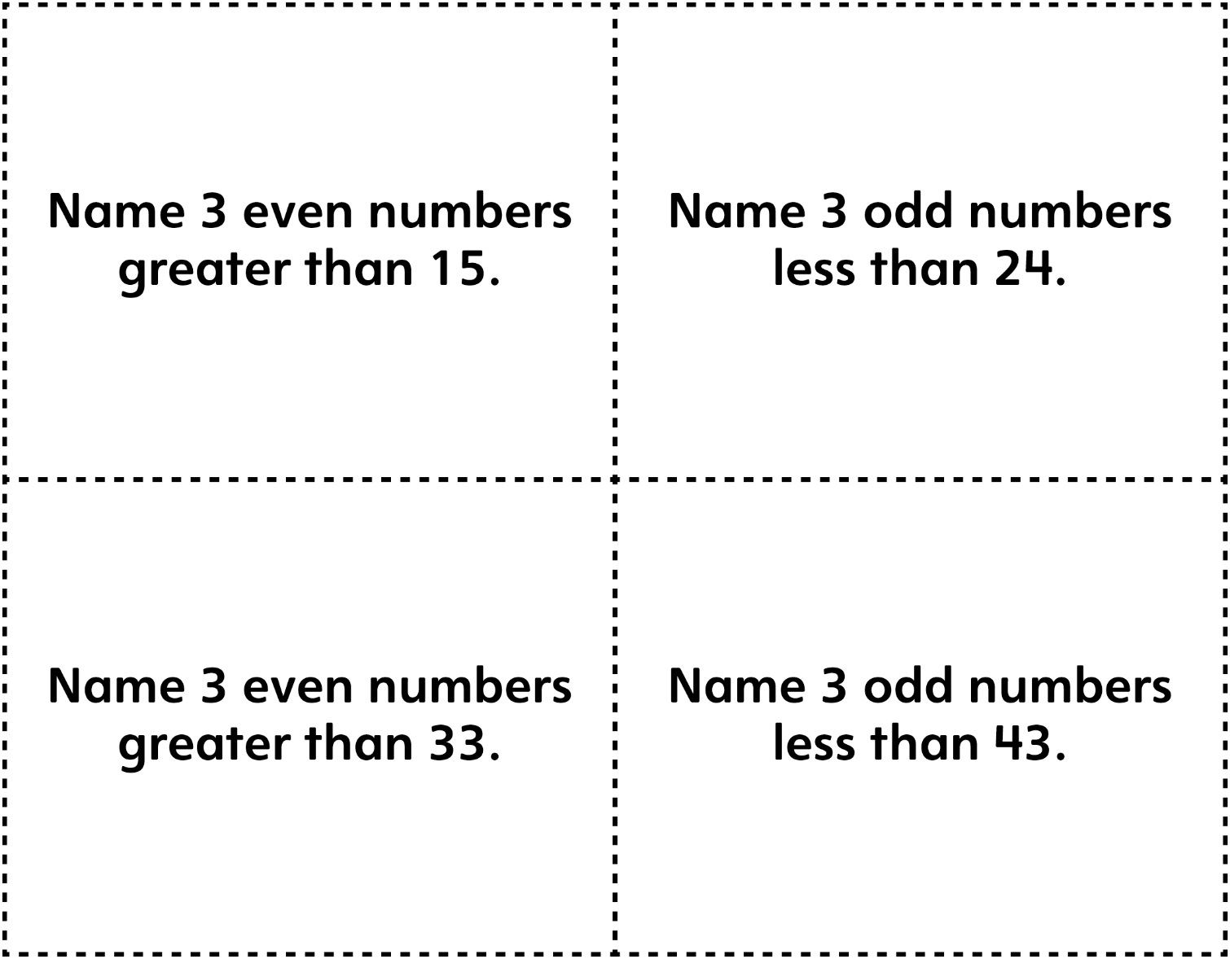

Task Cards: Odd or Even Numbers
Master 32b

(for Accommodations)

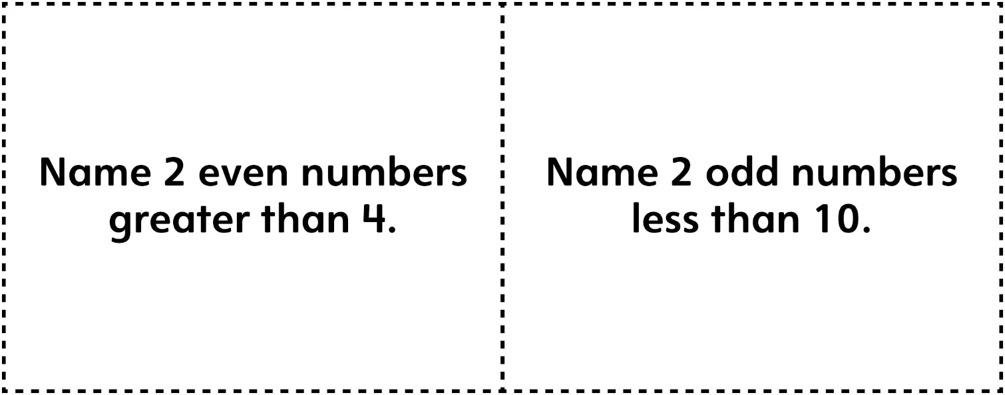

Task Cards: Comparing and Ordering
Master 32c

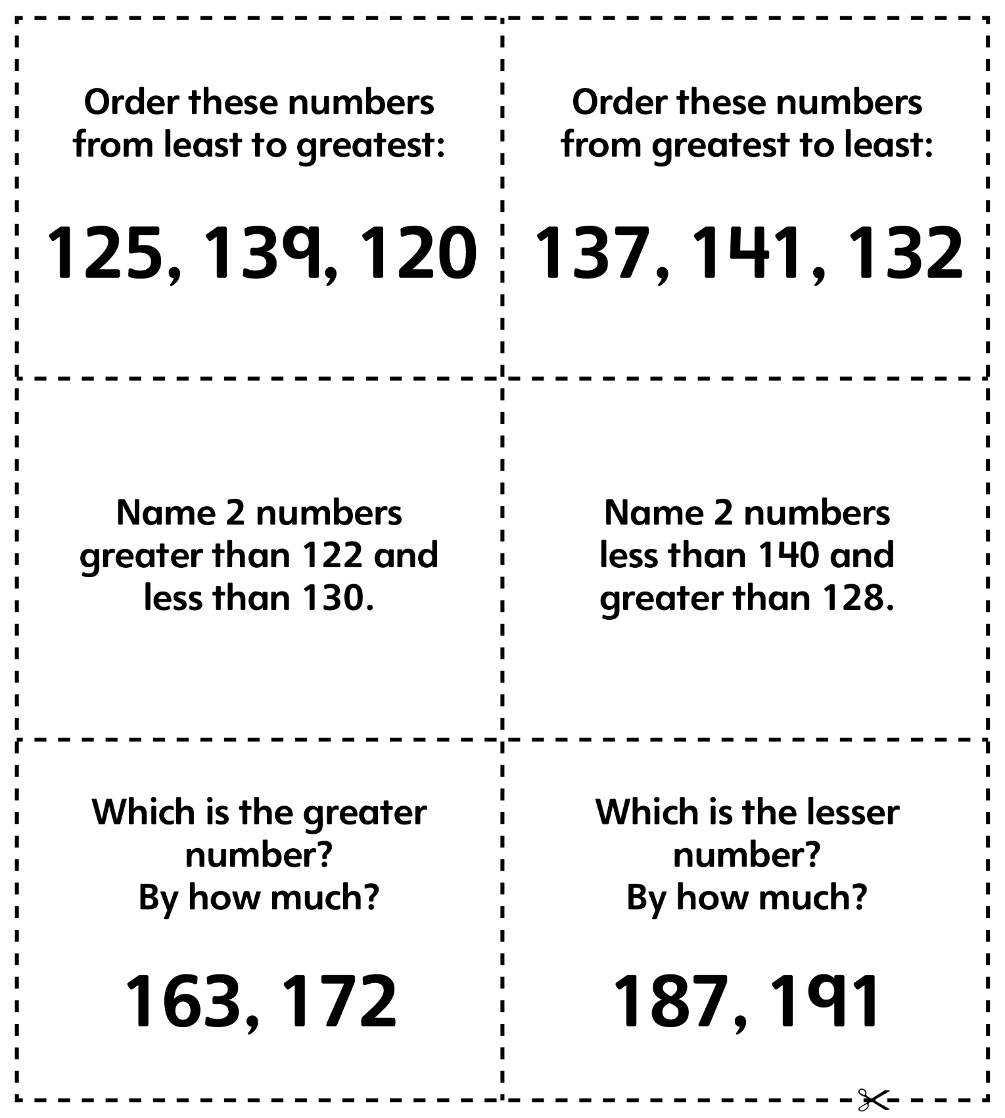

Task Cards: Comparing and Ordering
Master 32d

(for Accommodations)

