Comparing and Ordering Numbers to 200 Behaviours/Strategies
- Student makes 3-digit numbers but doesn’t know whether a number is greater than or less than 150.  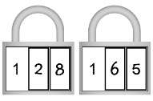  “I don’t know which one is greater than 150.” |  | - Student makes 3-digit numbers, but struggles to place them accurately on the number line.  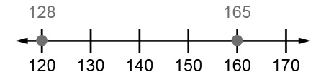 |  | - Student models numbers with manipulatives to help order on number line.  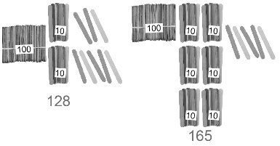
Observations/Documentation
- Student recites counting sequence or uses hundred chart to order numbers.  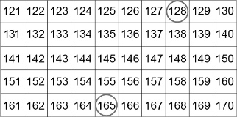  “165 is greater because it is farther down on the hundred chart.” |  | - Student compares, digit by digit.  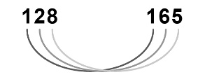  “Both have 1 hundred. 128 has 2 tens and 165 has 6 tens. So, 165 is greater than 128.” |  | - Student successfully uses benchmarks to compare and order.  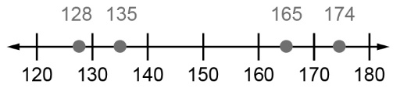  “The numbers from least to greatest are: 128, 135, 165, 174.”
Observations/Documentation

