**Number Cards (1–20)**

**Master 27a**

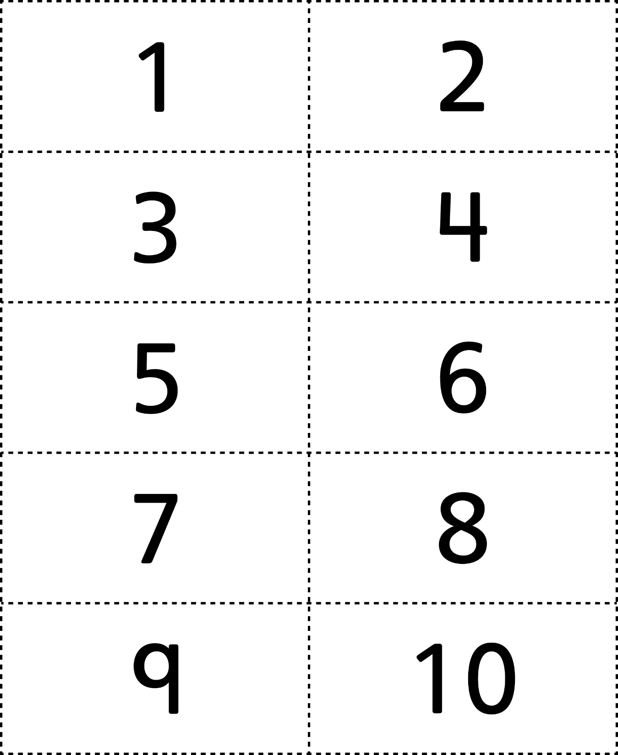

**Number Cards (1–20)**

**Master 27b**

