**Hundred Chart**

**Master 38a**

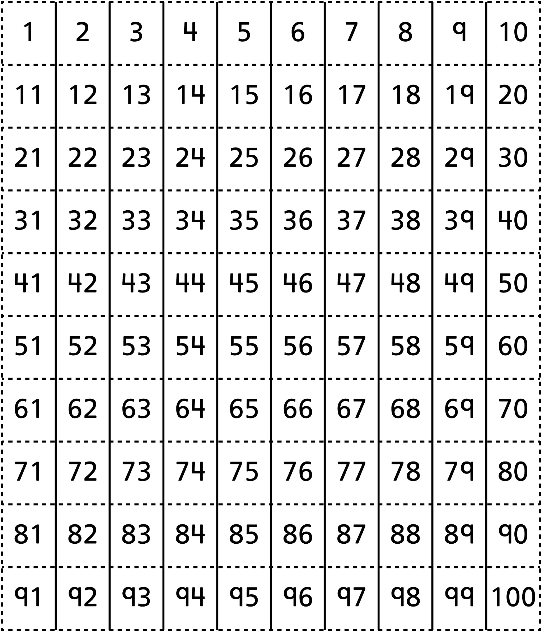

**Hundred Chart (101–200)**

**Master 38b**

