Determining 10 More/Less Behaviours/Strategies
- Student tapes rows together, but struggles to  say the number name sequence forward (rows are not in numerical order).  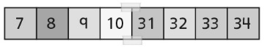 | - Student correctly says the number name  sequence forward (tapes rows together in  numerical order), but has difficulty seeing the  similarities and differences between a hundred chart and number line.  “They don’t look the same to me at all.” | - Student successfully builds the number line, but  does not recognize that numbers of the same  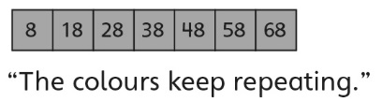  colour increase or decrease by 10.
Observations/Documentation
- Student recognizes that numbers of the same  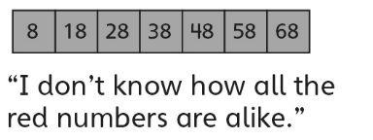  colour increase or decrease by 10, but struggles to see patterns and relationships between numbers of the same colour. | - Student determines 10 more/less than a number that is a multiple of ten, but struggles when the start number is not a multiple of ten.  “I don’t know ten more than 17.” | - Student successfully builds the number line,  recognizes all patterns, and fluently determines  10 more/less than a number without counting.
Observations/Documentation

