Regrouping Fractional Parts Behaviours/Strategies
- Student takes a block, but struggles to partition it into equal parts, and parts do not cover whole exactly. | - Student partitions wholes into equal parts, but  struggles to name the unit (does not know  fraction words).  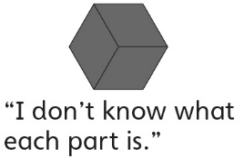 | - Student partitions wholes into equal parts,  but struggles to combine equal parts to make  wholes as he or she does not know how many  parts make a whole.  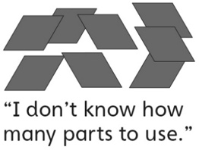
Observations/Documentation
- Student partitions wholes into equal parts,  but struggles to combine equal parts to make  wholes. | - Student combines equal parts to make wholes, but struggles to name the wholes and leftover parts.  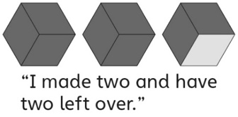 | - Student successfully partitions wholes into  equal parts, names the unit, and combines  equal parts to make wholes.  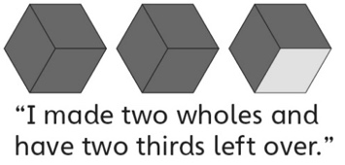
Observations/Documentation

