Comparing and Regrouping Fractional Parts Behaviours/Strategies
- Student chooses a whole, but struggles to partition it into equal parts, and parts are not equal or they do not cover the whole exactly.  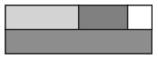 | - Student partitions wholes into equal parts, but compares parts of different wholes. | 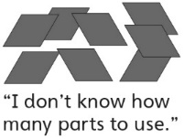  - Student partitions wholes into equal parts, but struggles to combine equal parts to make wholes. | - Student successfully partitions wholes into equal parts, compares with unit fractions, and combines equal parts to make wholes.
Observations/Documentation
Partitioning Sets Behaviours/Strategies
- Student shares items equally when there are no leftovers.  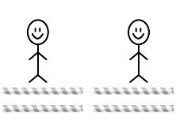  “I shared 4 straws and each person got 2 straws.” | - Student shares some items equally but is not sure how to partition the leftover and then name it.  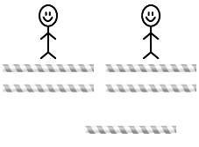  “I’m not sure  how to divide  the leftover  straw.” | - Student shares items equally, including leftovers, and uses fractions to name the amount each sharer gets.  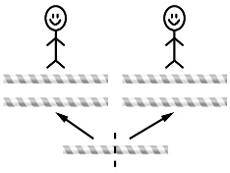  “Each person got  two and one-half  straws.” | 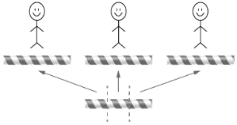  - Student shares items equally, including leftovers, and recognizes some equivalent fractions.  “Each person got  one and one-third  straws. If I cut the  leftover straw in sixths, each person gets one and two-sixths straws.”
Observations/Documentation
Master 64: Activity 22 Assessment
Number
Early Fractional Thinking: Consolidation

