Closer To Cards
Master 66a

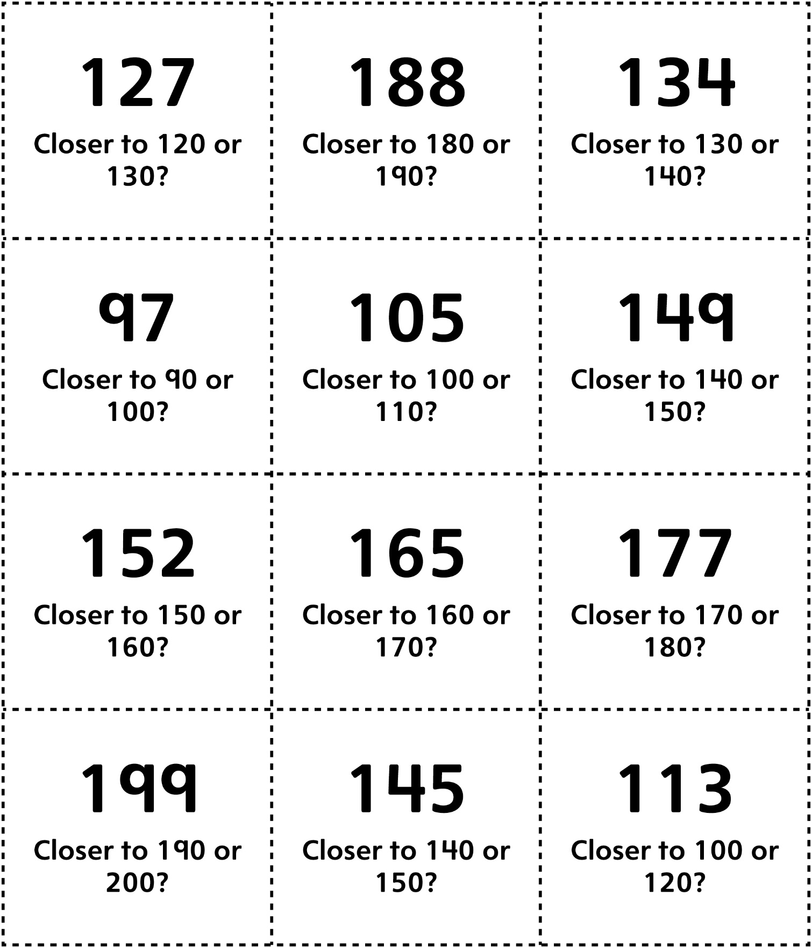

Closer To Cards (for Accommodations)
Master 66b

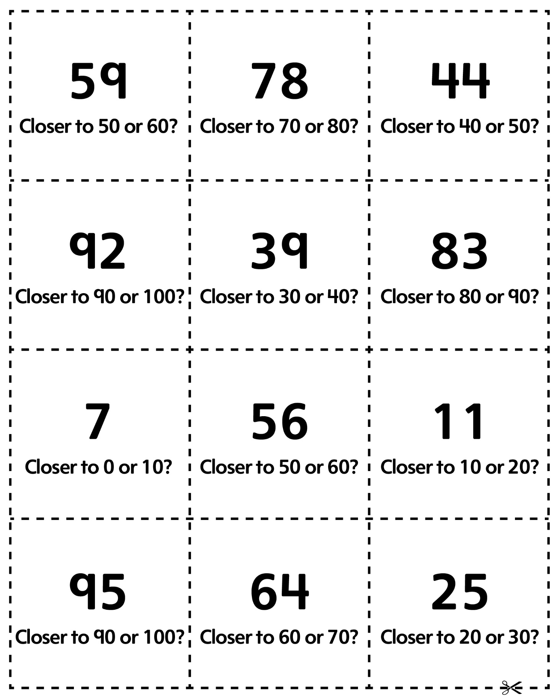
Closer To Cards
Master 66c

(for Combined Grades Extension)
