**Target Number Cards**

**Master 68a**

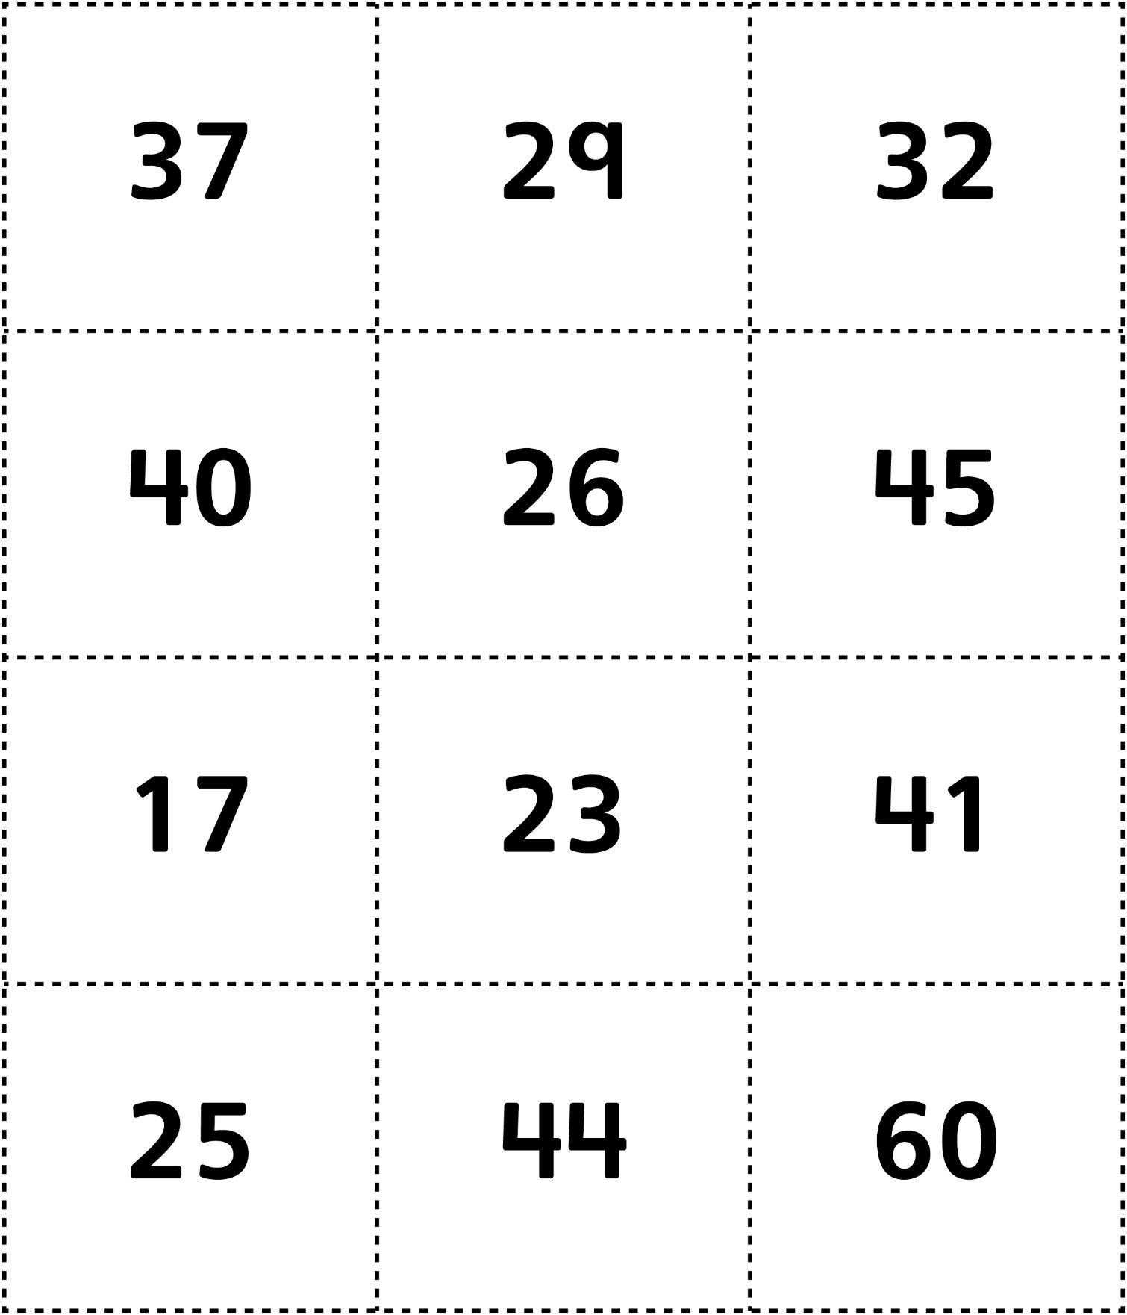

**Target Number Cards**

**Master 68b**

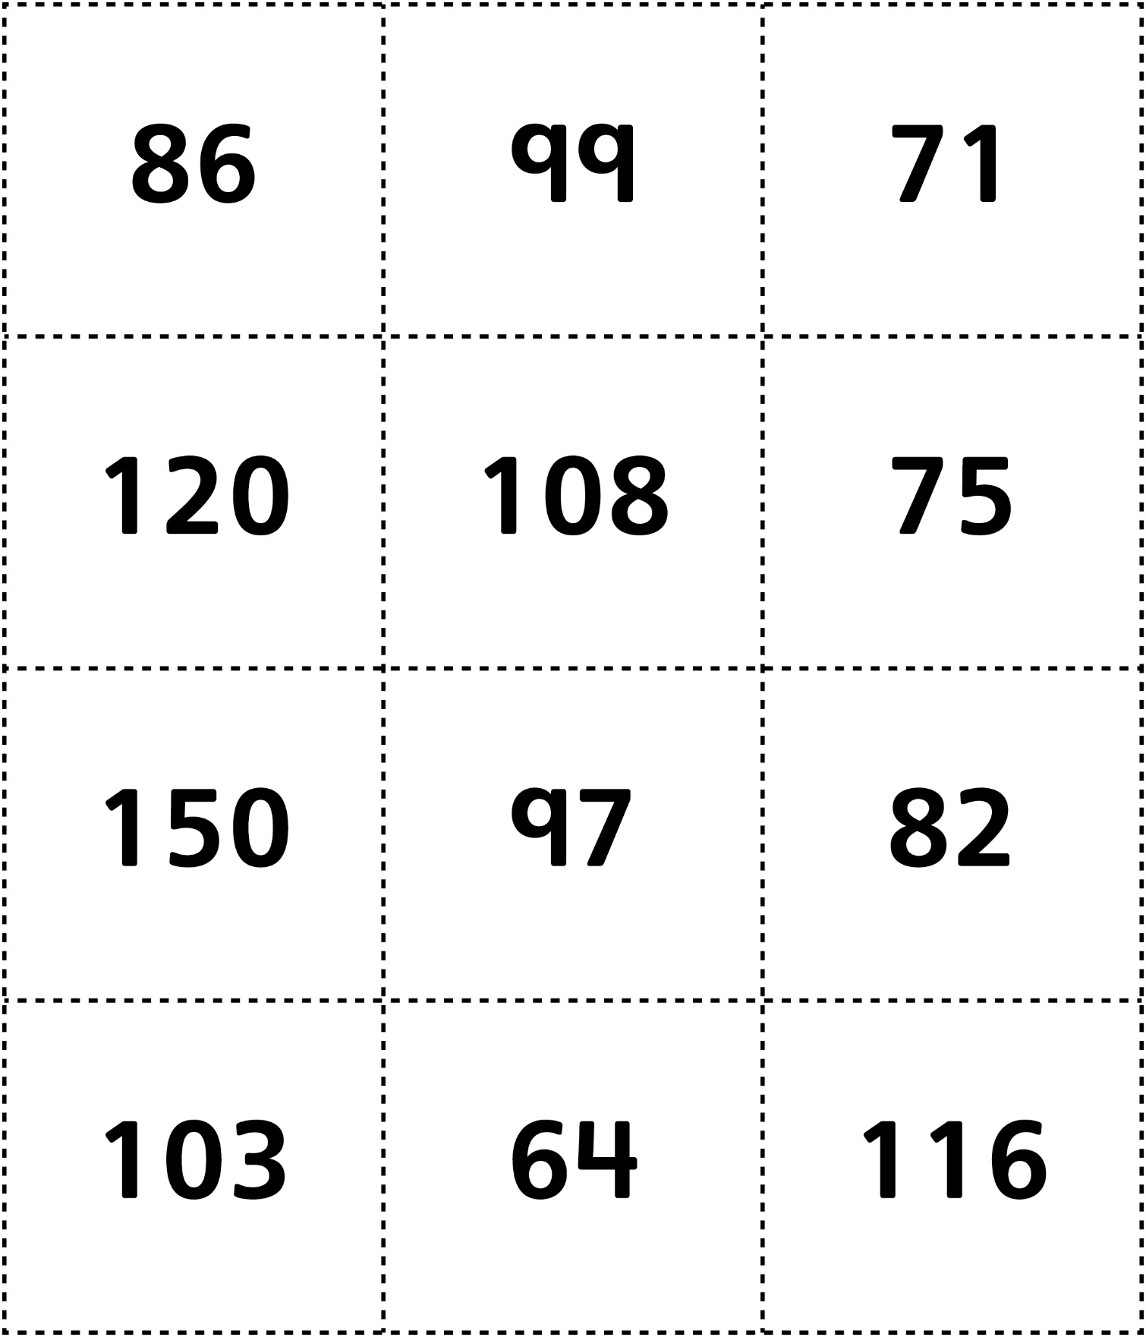

**Target Number Cards (for Accommodations)**

**Master 68c**

