**Story Problems 3**

**Master 82a**

**(Part Unknown: Joining)**

**Note:** Story Problem Card 3 is for use as an accommodation. 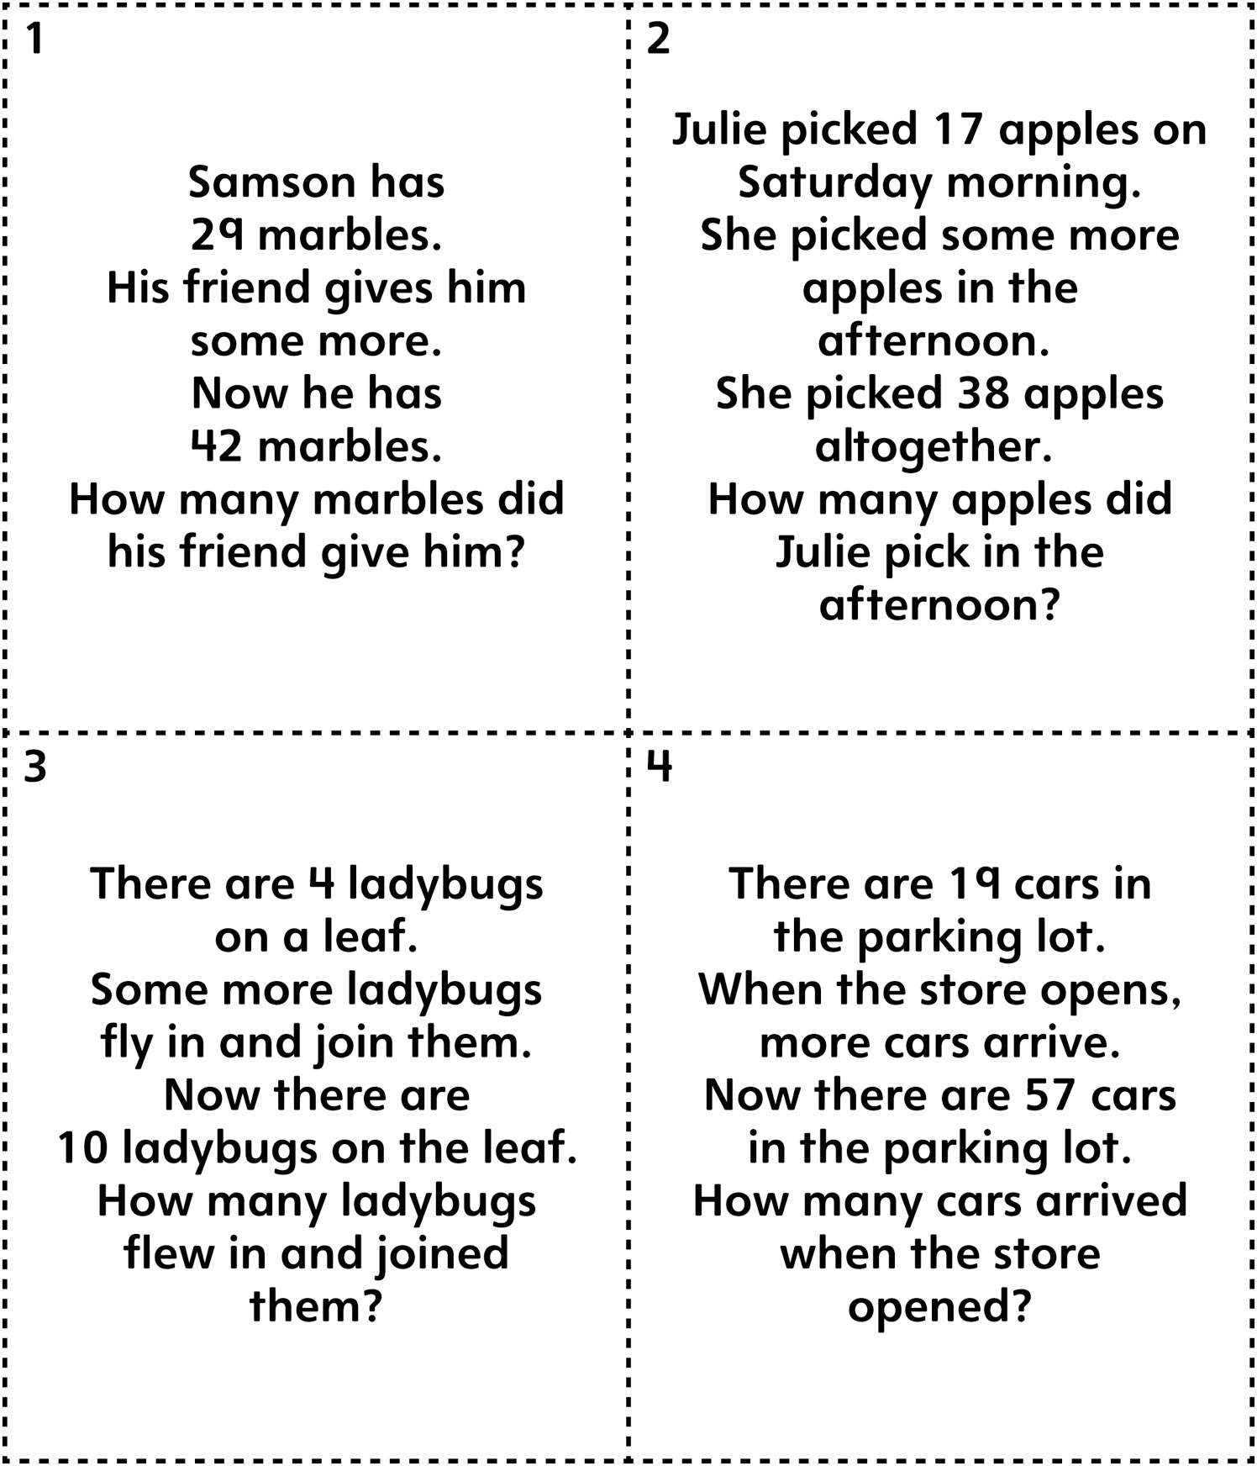

**Story Problems 3**

**Master 82b**

**(Part Unknown: Joining)**