How Many Halves or Fourths?
Master 109

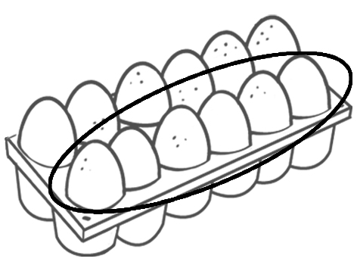
How many…
halves are in 1 dozen eggs? | halves are in 2 dozen eggs?
halves are in 3 dozen eggs? | halves are in 4 dozen eggs?
halves are in 5 dozen eggs? | halves are in 6 dozen eggs?
Which problem could you solve with the number sentence
$$\frac{1}{2}+\frac{1}{2}+\frac{1}{2}+\frac{1}{2}= ?$$

How many…
fourths are in 1 orange? | fourths are in 2 oranges?
fourths are in 3 oranges? | fourths are in 4 oranges?
fourths are in 4 oranges? | fourths are in 6 oranges?
Which problem could you solve with the number sentence
$$\frac{1}{4}+\frac{1}{4}+\frac{1}{4}+\frac{1}{4}+\frac{1}{4}+\frac{1}{4}+\frac{1}{4}+\frac{1}{4}+\frac{1}{4}+\frac{1}{4}+\frac{1}{4}+\frac{1}{4}= ?$$
