Repeated Addition and Multiplication Behaviours/Strategies
- Student uses repeated addition  of groups of cubes to solve the  problem, but miscounts or makes  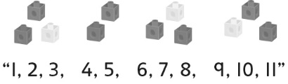  groups of different sizes. | - Student uses repeated addition  of groups to solve the problem by  modelling with groups of cubes. | - Student uses repeated addition  of groups to solve the problem by  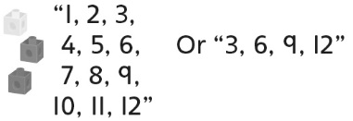  modelling with one group of cubes. | 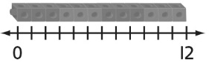  - Student uses repeated addition of groups to solve the problem by placing trains of cubes on a number line and then counting by 1s or skip-counting.
Observations/Documentation
- Student uses repeated addition  of groups to solve the problem by  taking equal jumps on a number  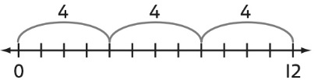  line, but mixes up the length of the arc with the number of items. | - Student uses repeated addition  of groups to solve the problem by  taking equal jumps on a number  line, but struggles to write a  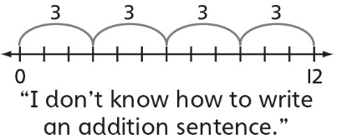  repeated addition sentence. | - Student uses repeated addition  of groups to solve the problem by  taking equal jumps on a number  line, writes a repeated addition  sentence, but struggles to write a  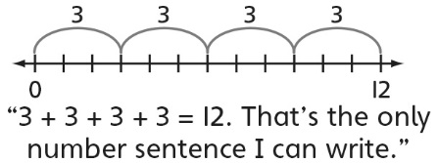  multiplication sentence. | - Student successfully uses repeated addition of groups to solve the problem, writes a repeated addition sentence, and uses multiplication symbol to symbolize the operation.
Observations/Documentation

