Equal Sharing Behaviours/Strategies
- Student turns over a card, but  struggles to say the number name sequence forward and does not start with correct number of items. | - Student shares items, but does not share the items equally. | - Student shares items equally by  sharing one item at a time. | - Student successfully shares items equally by sharing more than one item at a time (partitive sharing).
Observations/Documentation
Equal Grouping Behaviours/Strategies
- Student arranges objects in groups, but not all groups are of the same size. | - Student arranges objects in equal groups, but ignores the leftovers.  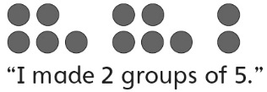 | - Student arranges objects in equal groups, but struggles to write a number sentence. | - Student arranges objects in equal groups and writes a repeated addition (subtraction) and multiplication (division) sentence.  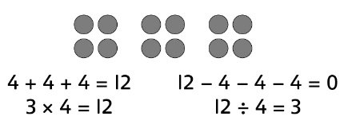
Observations/Documentation

