**Money Cutouts**

**Master 119a**

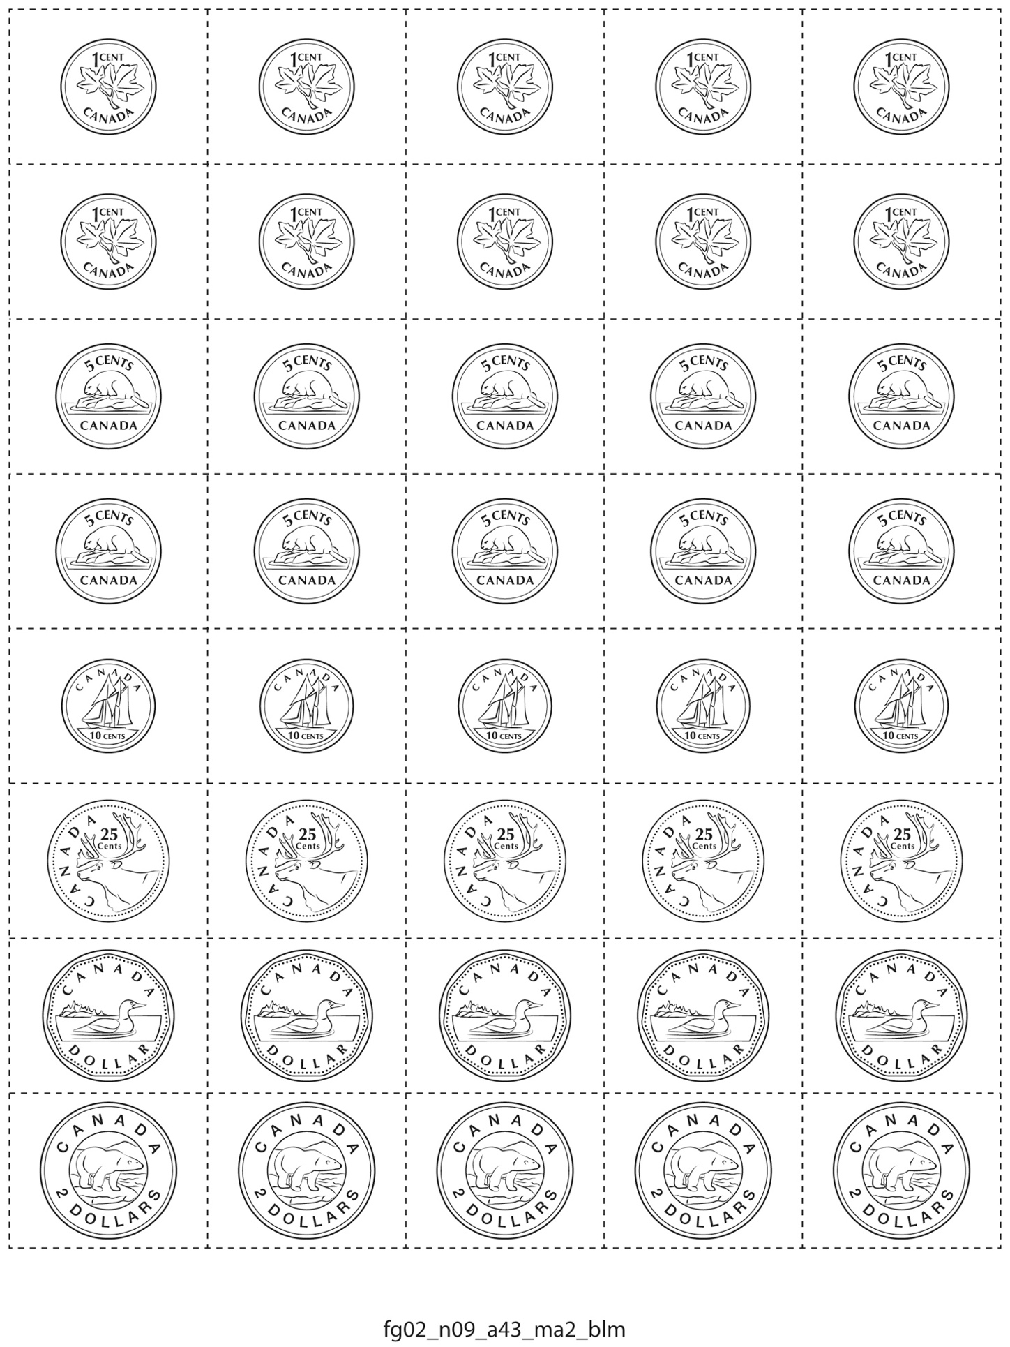

**Money Cutouts**

**Master 119b**

