Decomposing Money Amounts Behaviours/Strategies
- Student chooses jobs, but is unable to decompose money amounts into parts as he or she does not know the value of coins. | - Student chooses jobs, but is unable to decompose money amounts into parts and chooses coins randomly.  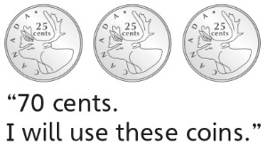 | - Student decomposes money  amounts into parts, but always  uses one denomination of coin. | - Student successfully decomposes money amounts into parts.
Observations/Documentation
Counting Money Amounts Behaviours/Strategies
- Student takes money from partner, but is unable to skip-count to find the value of the coins (unable to compose money amounts from parts). | - Student composes money  amounts from parts, but  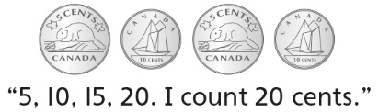  struggles when coins are of mixed denominations. | - Student composes money  amounts from parts and skip-counts to count coins of different  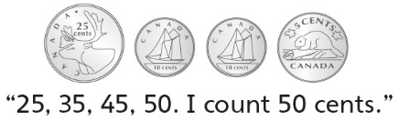  denominations. | - Student successfully and flexibly  composes money amounts from  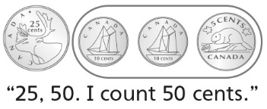  parts.
Observations/Documentation

