Two Attributes Changing (Part 1)
Master 9a

What attributes change in each pattern? Circle the core.
What is the pattern in each attribute?

Attributes changing: __________________________________________
___________________________________________________________

Pattern in first attribute: ________________________________________
___________________________________________________________

Pattern in second attribute: _____________________________________
___________________________________________________________

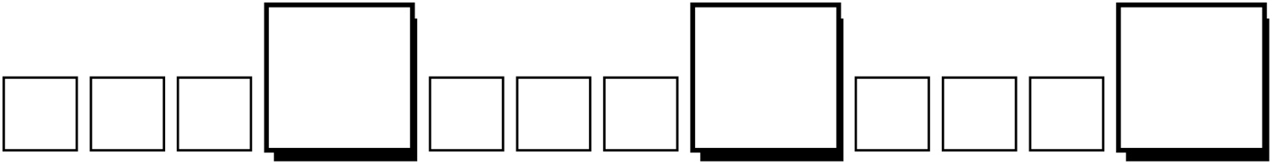

Attributes changing: __________________________________________
___________________________________________________________

Pattern in first attribute: ________________________________________
___________________________________________________________

Pattern in second attribute: _____________________________________
___________________________________________________________
Two Attributes Changing (Part 2)
Master 9a

What attributes change in each pattern? Circle the core.
What is the pattern in each attribute?

Attributes changing: _______________________________________
_______________________________________________________

Pattern in first attribute: ____________________________________
_______________________________________________________

Pattern in second attribute: _________________________________
_______________________________________________________

Attributes changing: _______________________________________
_______________________________________________________

Pattern in first attribute: ____________________________________
_______________________________________________________

Pattern in second attribute: _________________________________
_______________________________________________________
Two Attributes Changing
Master 9b

(for Accommodations)

Circle the core.

Size pattern:

__________ _________ __________ _________ __________ ________

Colour pattern:

__________ _________ __________ _________ __________ ________

Colour pattern:

__________ _________ ___________ _________ __________ _________

Shape pattern:

__________ _________ ___________ _________ __________ _________

Try this one on your own.

__________________ :

____________ __________ ____________ __________ ____________ __________

__________________ :

____________ __________ ____________ __________ ____________ ___________

