Creating Increasing/Decreasing Patterns Behaviours/Strategies
- Student chooses materials, but struggles to  create an increasing/decreasing pattern and randomly groups items or creates a repeating pattern.  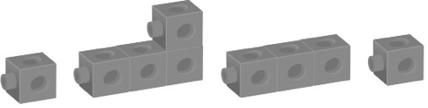 | - Student chooses materials and attempts to  create an increasing/decreasing pattern, but does not add/subtract the same number of items each time.  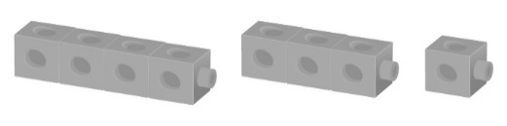 | - Student creates an increasing/decreasing pattern, but items are not added/subtracted in the same way each time.  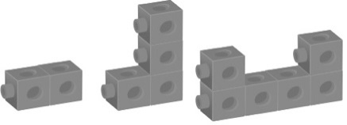
Observations/Documentation
- Student creates an increasing/decreasing pattern, but struggles to write the pattern rule.  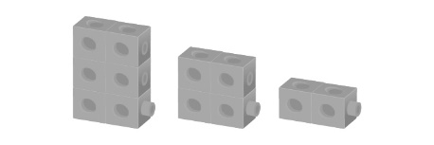  “Subtract 2.” | - Student creates an increasing/decreasing pattern, but is not sure if partner’s pattern rule is correct.  “I’m not sure if it’s right.” | - Student successfully identifies and creates an  increasing/decreasing pattern and explains the pattern rule.
Observations/Documentation

