Solving Problems Involving Increasing Patterns Behaviours/Strategies
- Student reproduces an increasing pattern  concretely, but is unable to identify and explain the pattern rule. | - Student identifies and reproduces an increasing pattern, but guesses to solve the problem (gives no thought to pattern).  “I guess 200!” | - Student identifies and reproduces an increasing  pattern, but struggles to use rule to make  prediction.  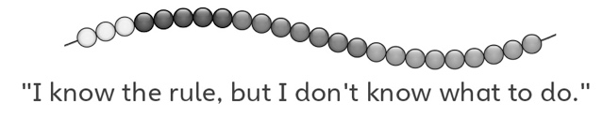
Observations/Documentation
- Student identifies and reproduces an increasing pattern and uses rule to make prediction, but struggles to extend the pattern to check. | - Student identifies, reproduces, and extends an increasing pattern to solve problem, but does not use math language to explain thinking. | - Student successfully identifies, reproduces, and  extends an increasing pattern to solve problem  and uses math language to explain thinking.
Observations/Documentation

