Increasing/Decreasing Pattern Cards
Master 22a

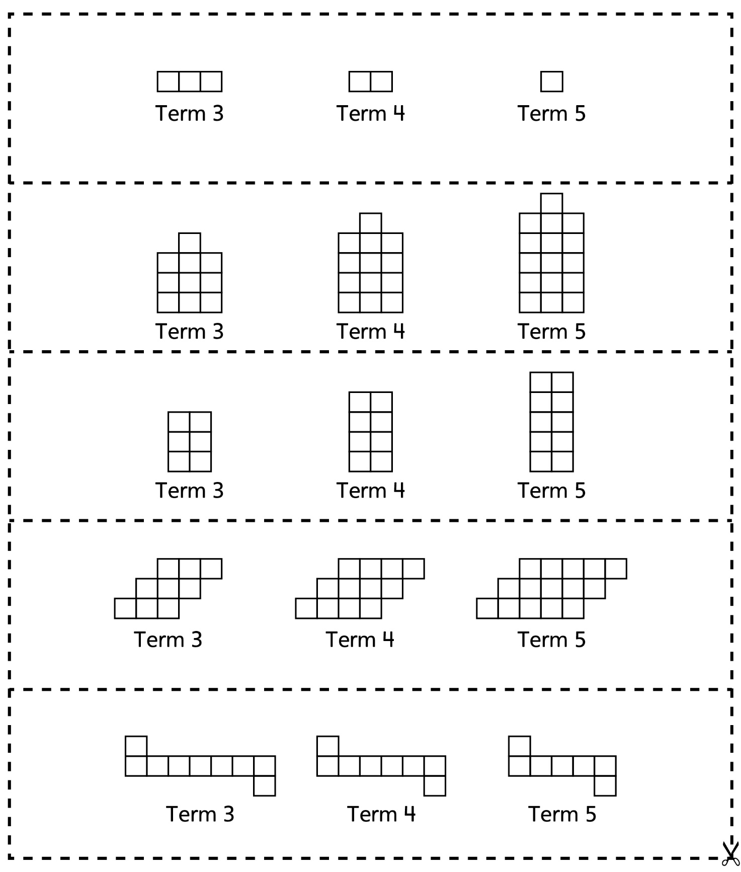

Increasing/Decreasing Pattern Cards
Master 22b

