Equal or Not Equal? Cards
Master 37a

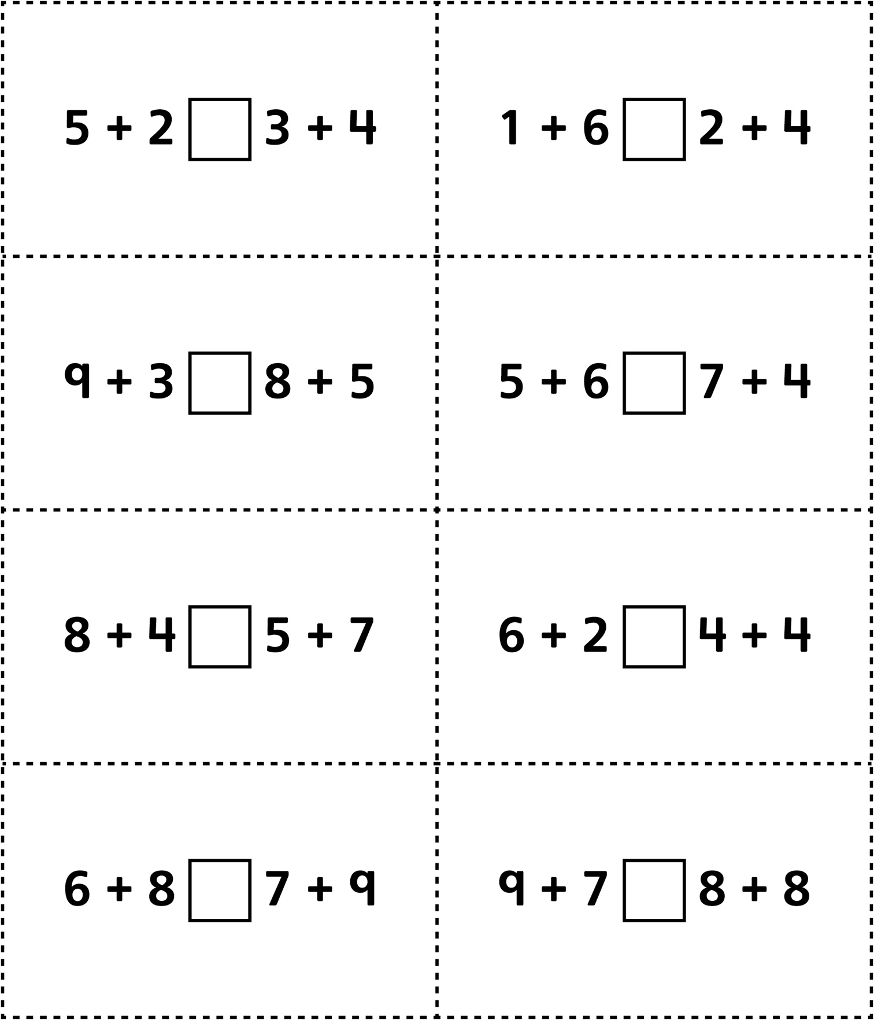
Equal or Not Equal? Cards
(for Accommodations)
Master 37b

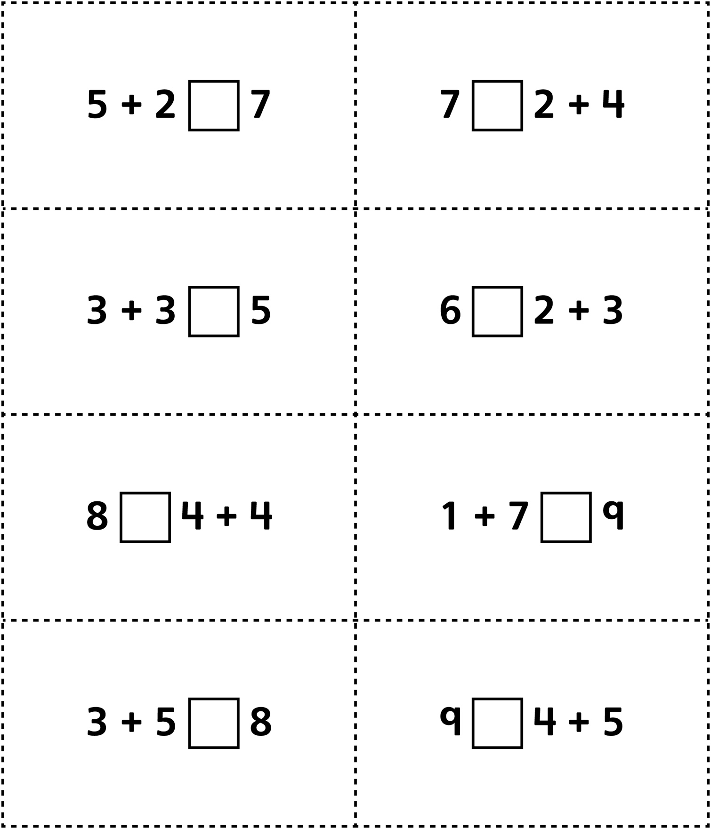
Equal or Not Equal? Cards
(for Extension)
Master 37c

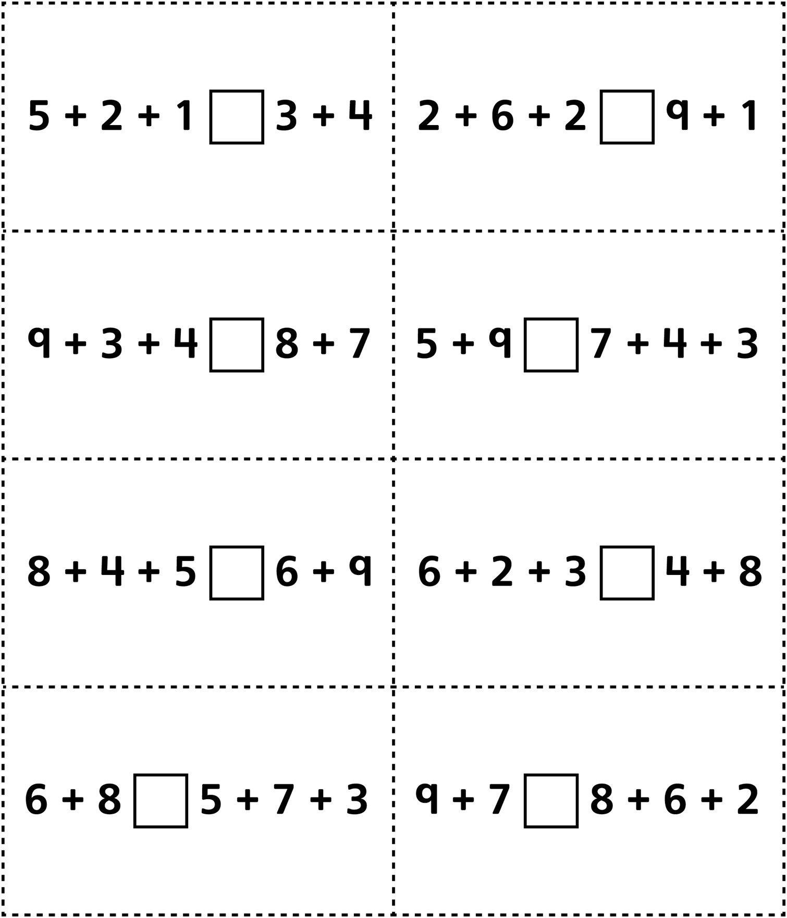
Equal or Not Equal? Cards
(for Combined Grades Extension)
Master 37d

