Number Sentence Recording Sheet
Master 49a

Our number: ______

+
=
+

+
=
+

+
≠
+

Number Sentence Recording Sheet
Master 49b

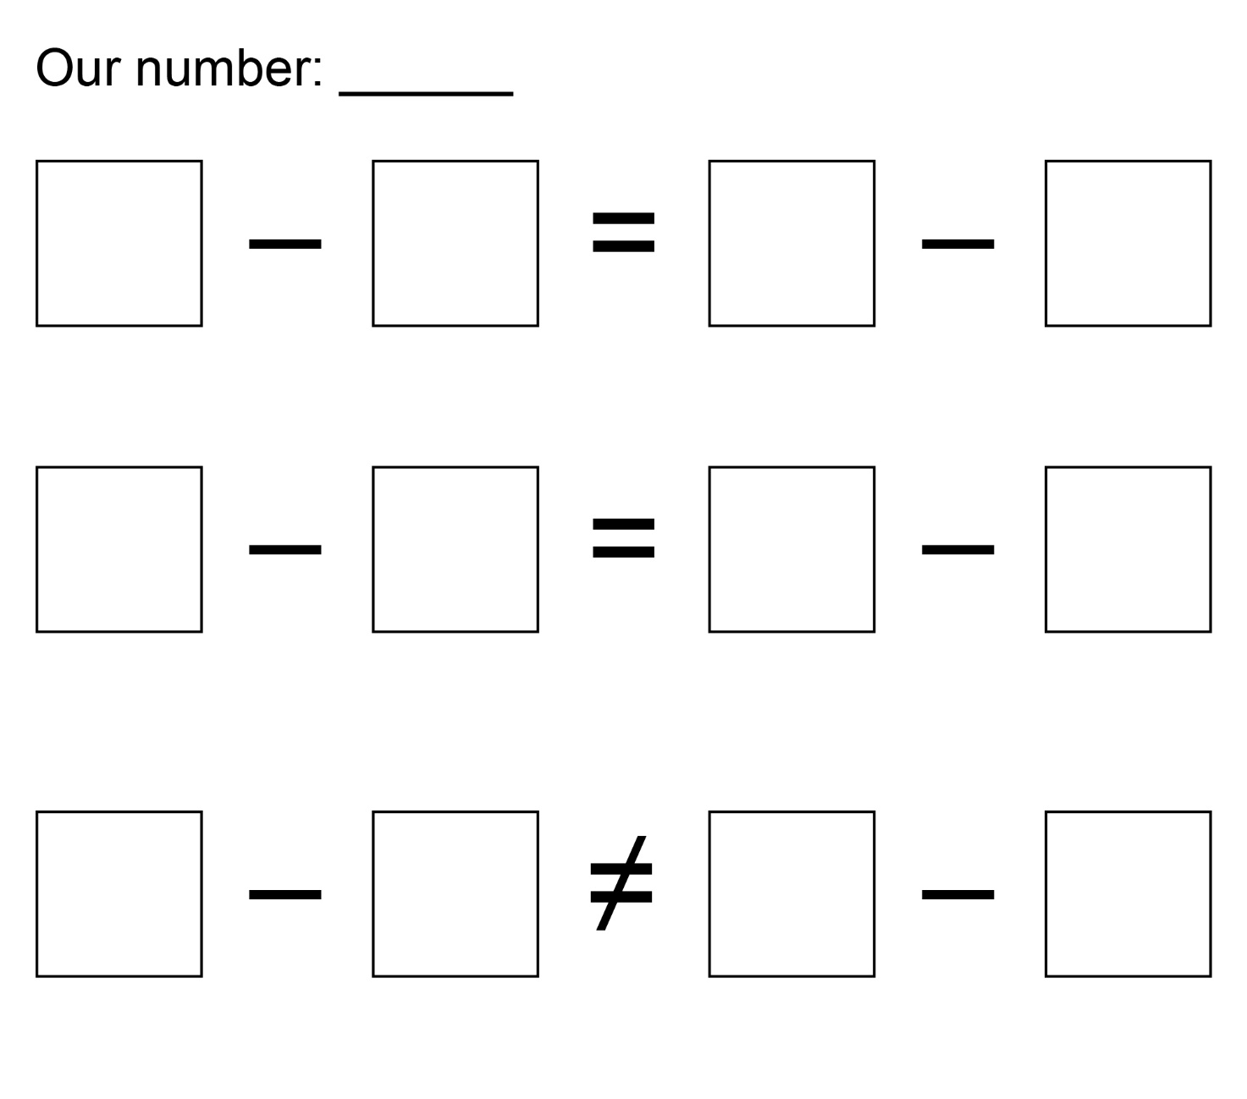

Number Sentence Recording Sheet
Master 49c

