Expressing Equality and Inequality Behaviours/Strategies
- Student chooses a number, but struggles to  decompose number into two parts. | - Student models equality with cubes, but  struggles to record different expressions of  the same quantity as equalities (cannot write  number sentence).  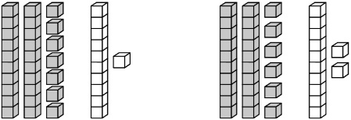  “What do I write?” | - Student writes number sentences for equalities,  but does not consider zero, or thinks the same  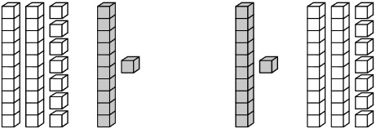  cubes in the opposite order is not an equality.  “How can these be equal?”
Observations/Documentation
- Student writes number sentences for equalities, but struggles to model or write number sentences for inequalities. | - Student writes number sentences for equalities, but struggles to use the not equal symbol when comparing expressions.  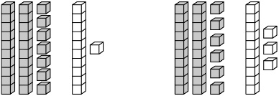  27 + 11 26 + 13 | - Student records different expressions of the same quantity as equalities, and understands and uses the equal (=) and not equal (≠) symbols when writing number sentences and comparing expressions.  17 + 23 = 18 + 22  17 + 23 ≠ 18 + 24
Observations/Documentation

