**Fill Me!**

**Intervention: Master 60a**

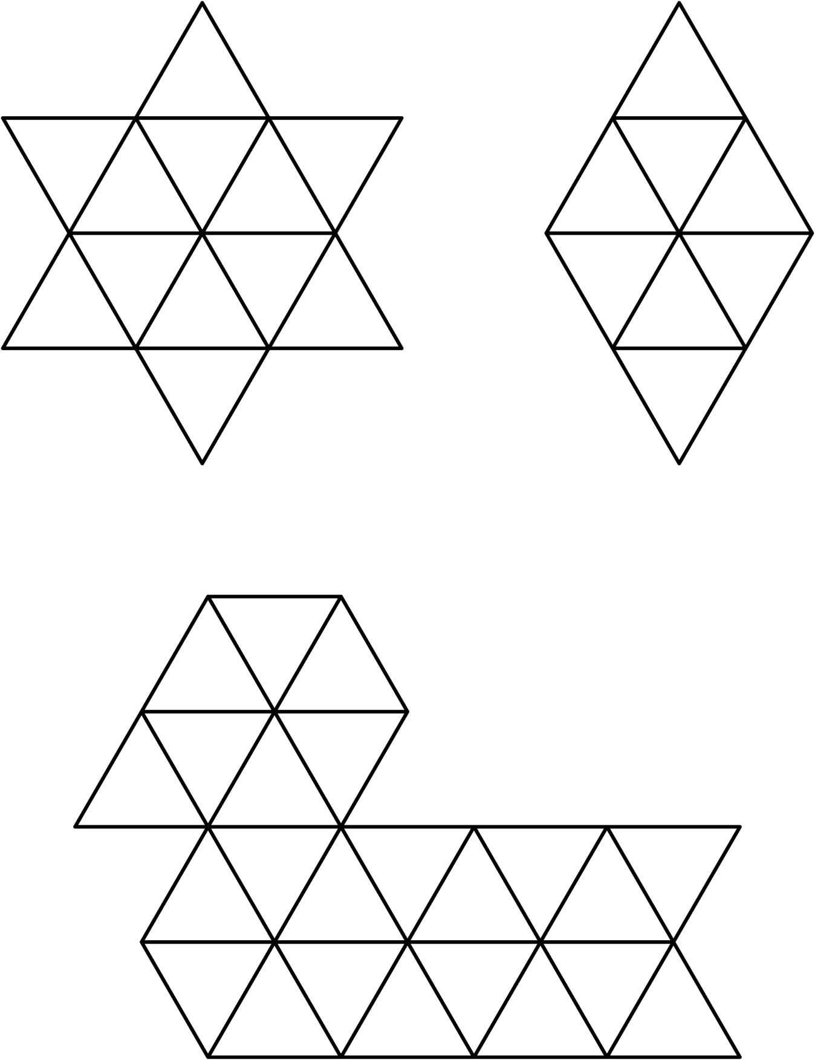

**Fill Me!**

**Intervention: Master 60b**

**(for Accommodations)**

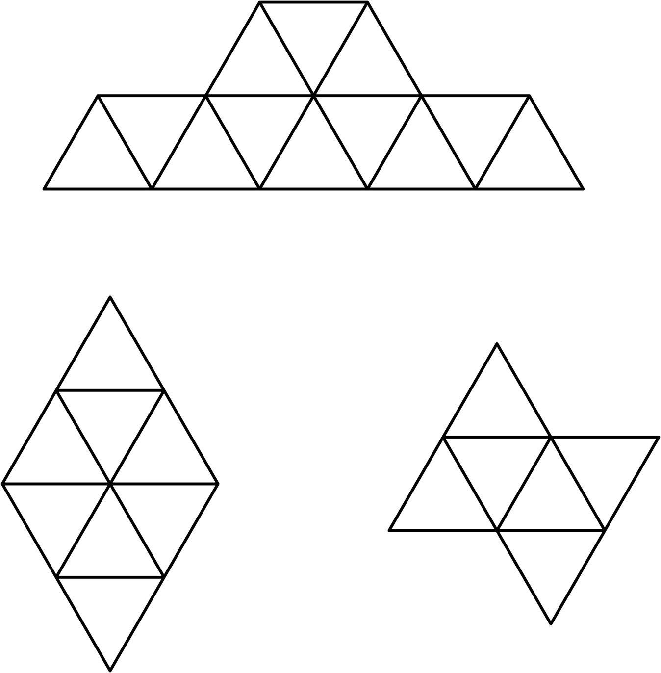

**Fill Me!**

**Intervention: Master 60c**

**(for Extension)**

