Giving Directions Behaviours/Strategies
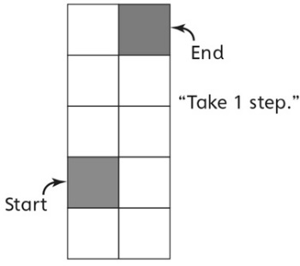  - Student looks at the ten-frame, but struggles to give simple directions, and directions are incomplete or incorrect. | 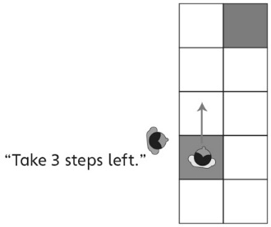  - Student gives simple directions, but does not  adjust them for partner’s perspective. | - Student gives accurate simple directions and  considers partner’s perspective.  “Take 3 steps forward.  Take 1 step right.  Take 1 step back.”
Observations/Documentation
Following Directions Behaviours/Strategies
- Student stands on start, but struggles to follow  simple directions or miscounts steps. | - Student follows simple directions, but relies on  the direction buddy to move left or right.  “I need the direction buddy to help.” | - Student follows simple directions to move quickly and easily to the end.
Observations/Documentation

