Measuring Length with Standard-Sized Objects Behaviours/Strategies
- Student records object, but struggles to  estimate its length with standard-sized objects.  “About 100 cubes!” | - Student uses standard-sized objects to  measure, but does not join cubes and leaves  gaps or overlaps.  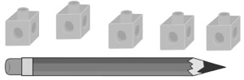 | - Student uses standard-sized objects to measure (e.g., 10-centicube rod), but does not line up the base of the first cube with the end of the object being measured.  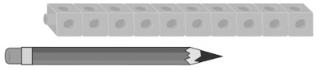
Observations/Documentation
- Student uses standard-sized objects to measure (e.g., 10-centicube rod), but ignores the leftover amount.  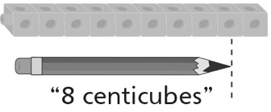 | - Student uses standard-sized objects to measure (e.g., 10-centicube rod), but forgets to include the unit when stating the measure.  “It is 8 long.” | - Student successfully uses standard-sized objects to measure (e.g., 10-centicube rod), and includes the unit with the measure.  “It is a little more than 8 centicubes long.”
Observations/Documentation

