Determining 10 or Multiples of 10 More Behaviours/Strategies
- Student counts three times to determine 10 or  multiples of 10 more than a number (models  with counters/cubes).  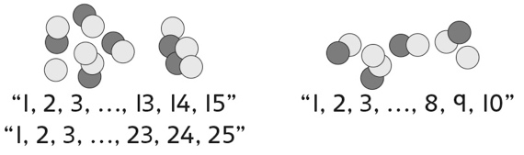 | - Student counts on to determine 10 or multiples of 10 more than a number (models with counters/cubes).  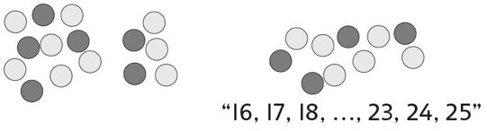 | - Student counts on by ones on a hundred chart to determine 10 or multiples of 10 more than a number.  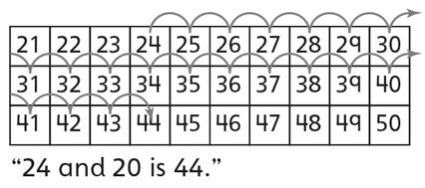
Observations/Documentation
- Student takes jumps of 10 forward on a hundred chart to determine 10 or multiples of 10 more than a number, but does not recognize how the tens digit changes.  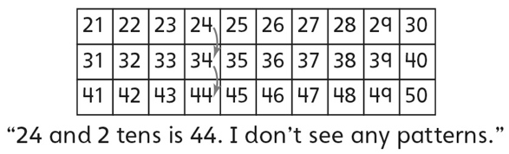 | - Student takes jumps of 10 forward on a  hundred chart to determine 10 or multiples of  10 more than a number and recognizes that the tens digit increases by 1 for each ten added.  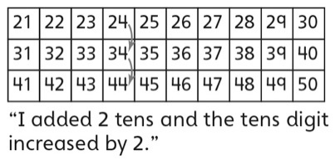 | - Student fluently determines 10 or multiples  of 10 more than a number without using the  hundred chart.
Observations/Documentation

