Partitioning Wholes into Equal Parts Behaviours/Strategies
- Student chooses an item, but struggles to partition it into equal parts, and parts are not all equal.  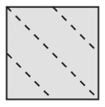 | - Student partitions wholes into equal parts, but  thinks that when the parts are not equal, they  still represent halves, fourths, and eighths.  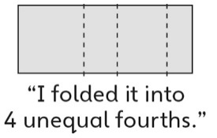 | - Student partitions wholes into 2 and 4 equal  parts, but struggles to partition wholes into  8 equal parts.
Observations/Documentation
- Student partitions wholes into equal parts, but  struggles to name the unit (does not know  fraction words).  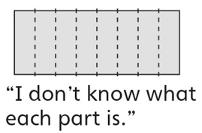 | - Student partitions wholes into equal parts,  but thinks that equal parts of different wholes  should be the same size.  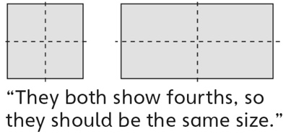 | - Student successfully partitions wholes into  equal parts and names the unit.
Observations/Documentation

