**Sample Graphs**

**Math Every Day: Master 16a**

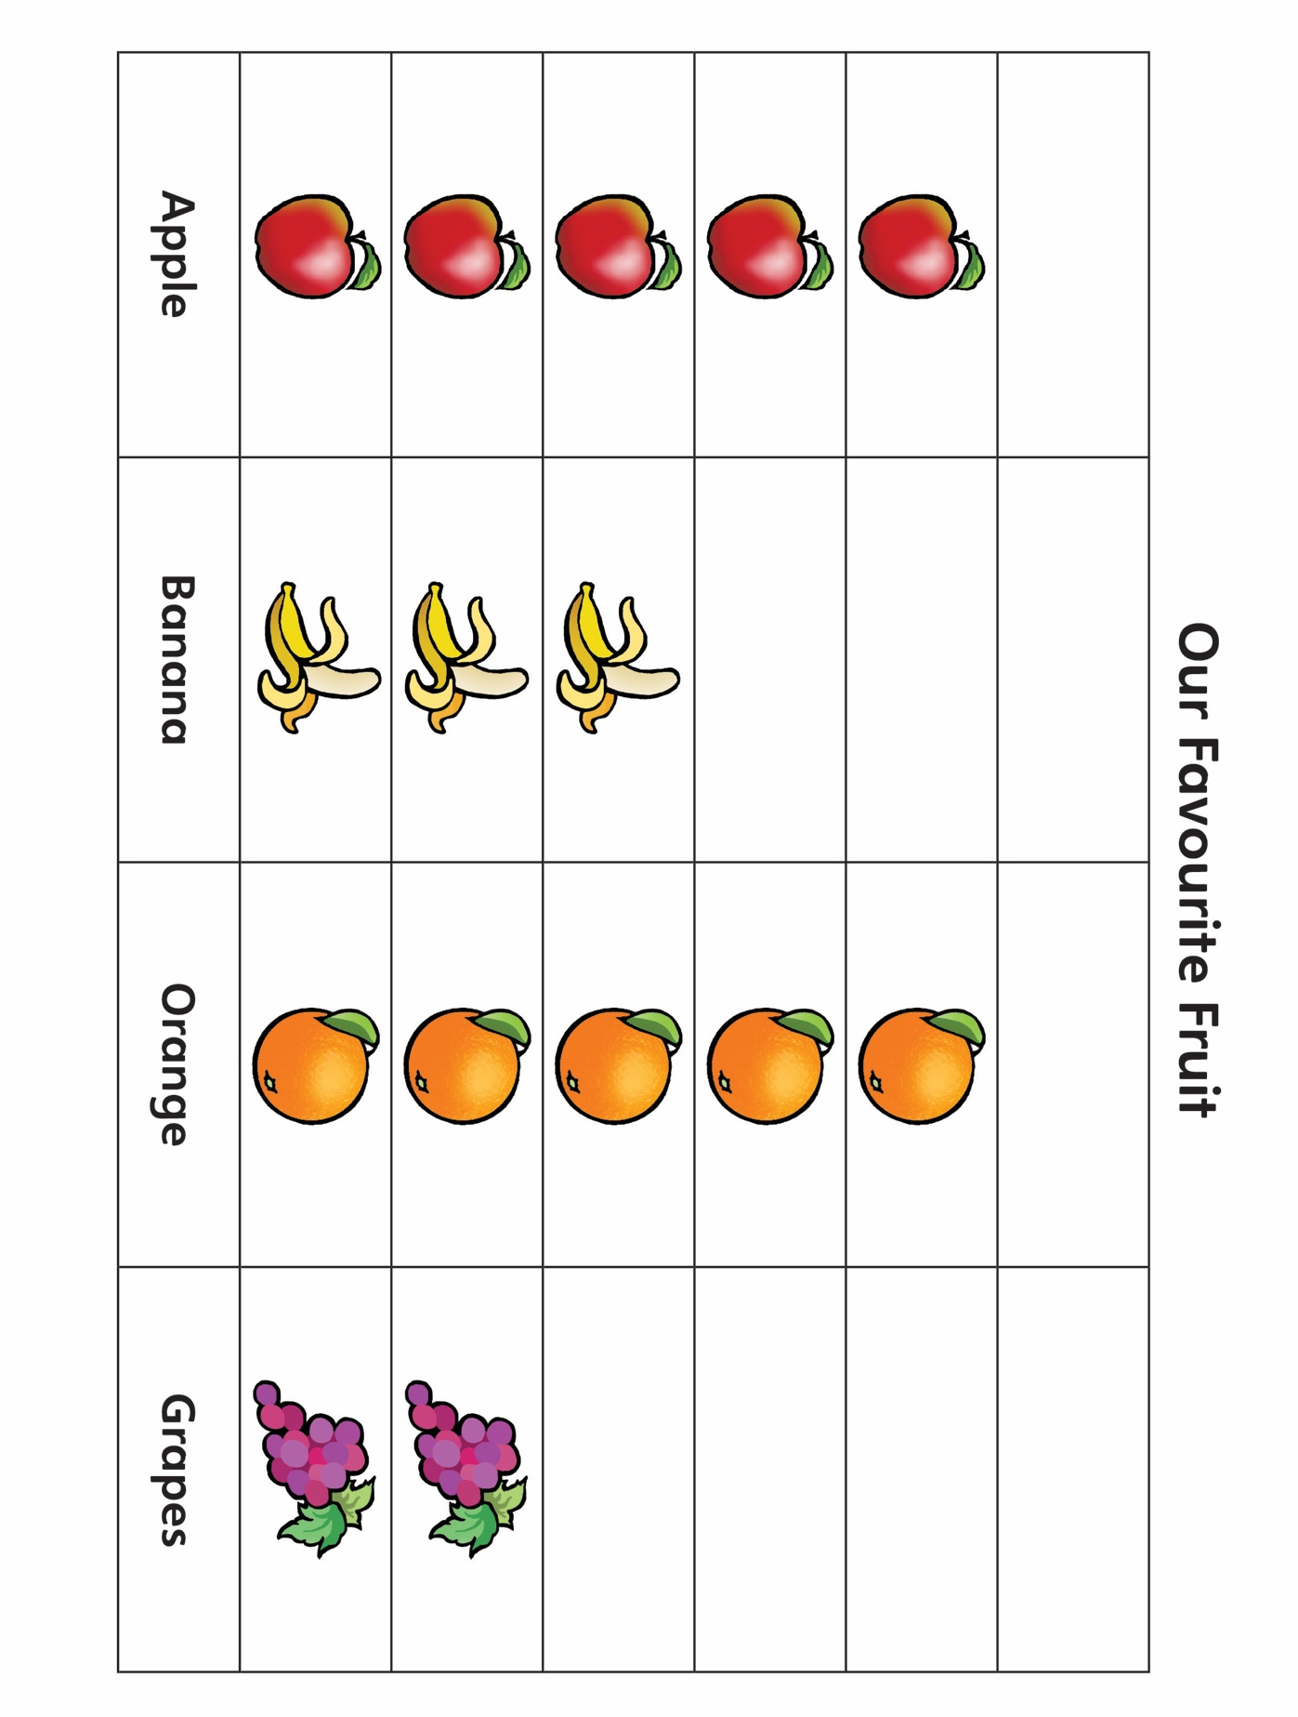

**Sample Graphs**

**Math Every Day: Master 16b**

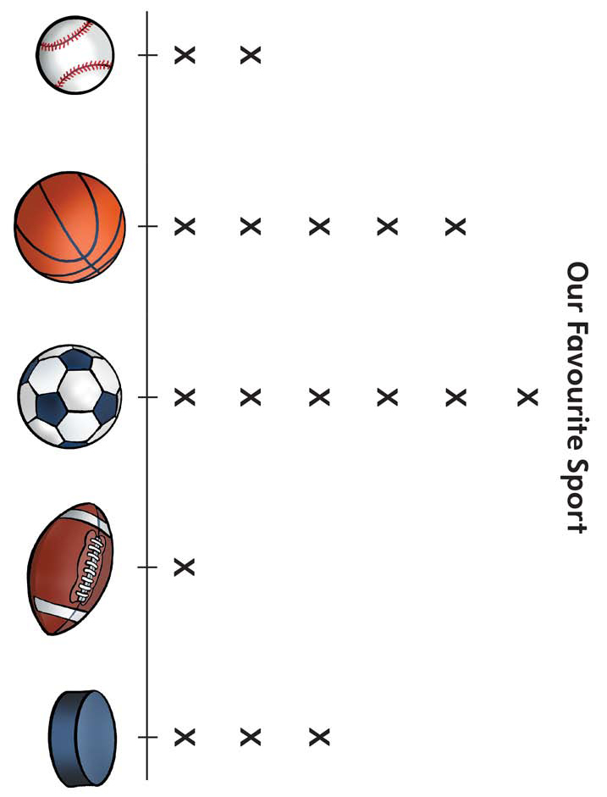

**Sample Graphs**

**Math Every Day: Master 16c**

