Consolidation Attribute Cards
Master 11a

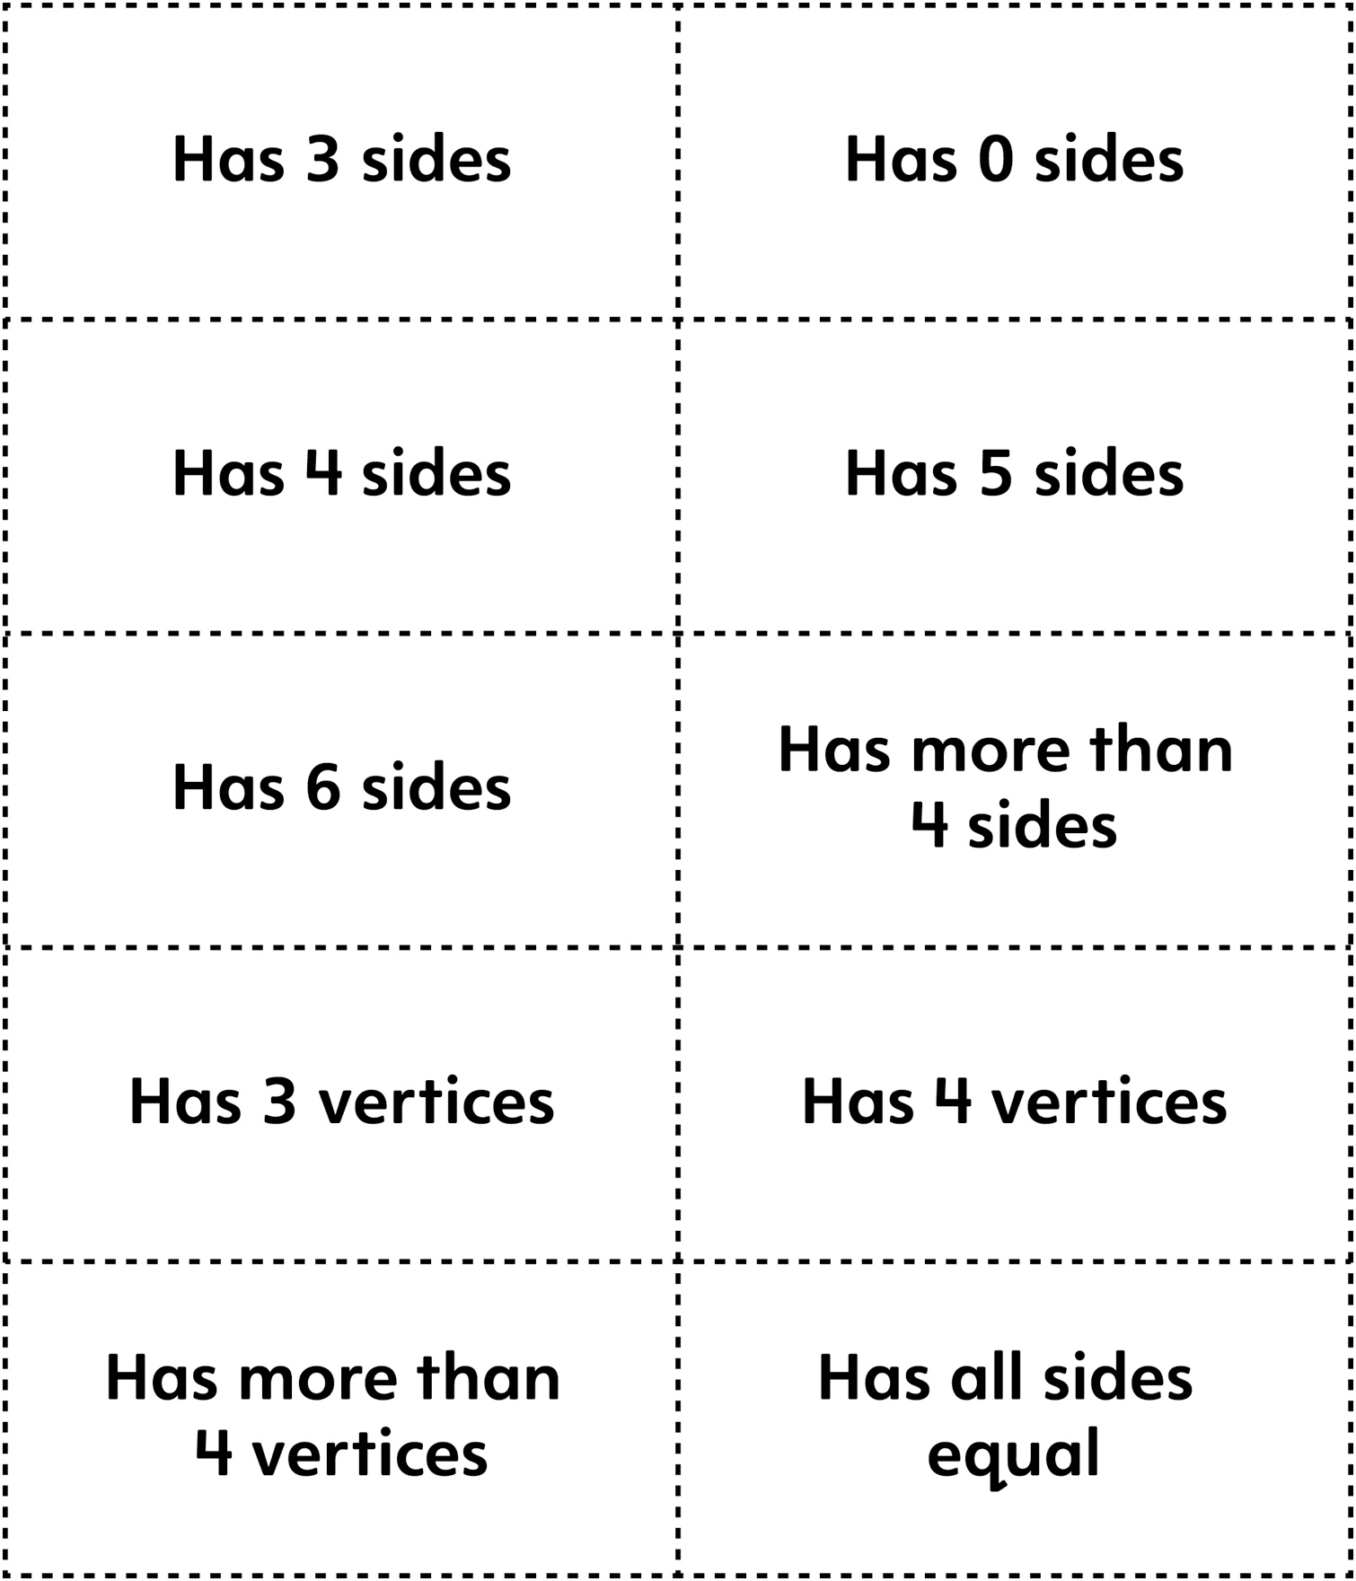

Consolidation Attribute Cards
Master 11b

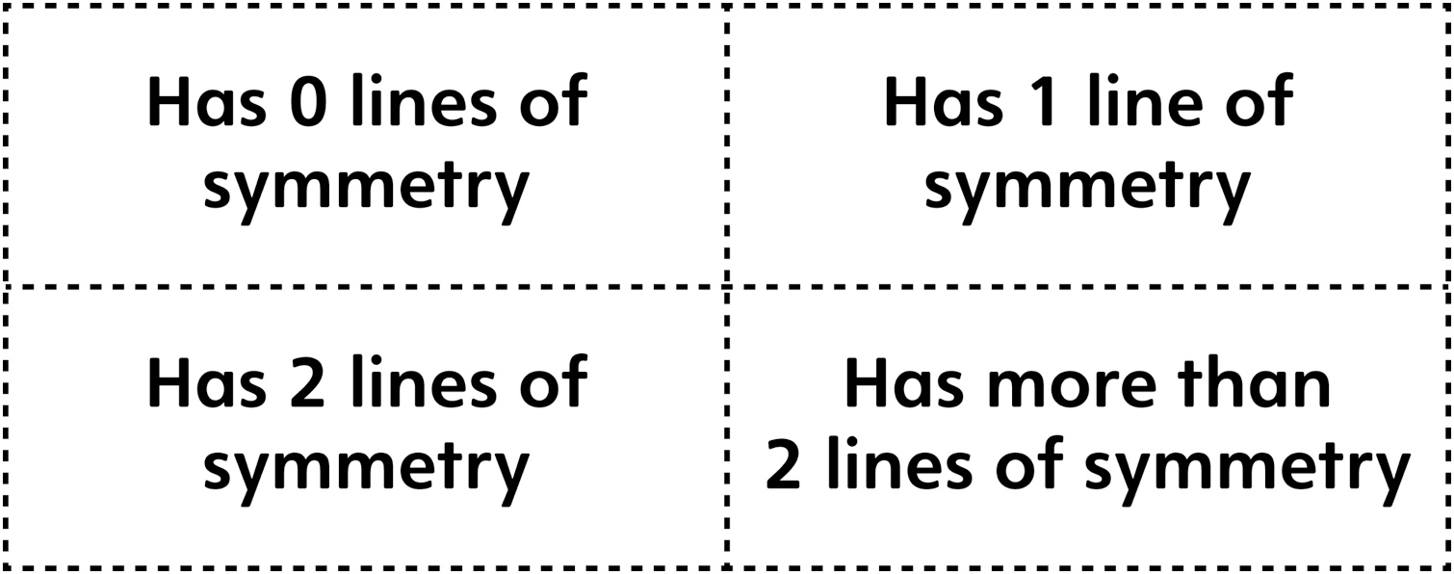

Consolidation Attribute Cards
(for Combined Grades Extension)
Master 11c

