Constructing 3-D Solids Behaviours/Strategies
- Student takes a card, but struggles to analyze  the geometric attributes of the solid. | - Student analyzes the geometric attributes of  the solid, but chooses inappropriate materials  to construct the solid.  “I am going to use cubes to make a sphere.” | - Student chooses appropriate materials, but  struggles to construct the solid with given attributes.  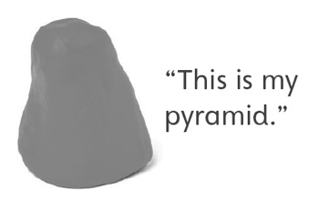
Observations/Documentation
- Student constructs solid with given attributes,  but thinks model must have same size and  orientation as solid in reference set.  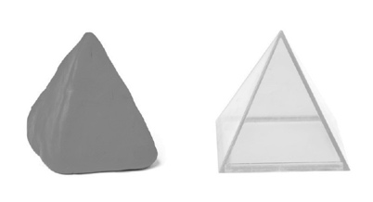 | - Student constructs 3-D solid with given  attributes, but struggles to compare solids. | - Student successfully constructs and compares  3-D solids with given attributes.  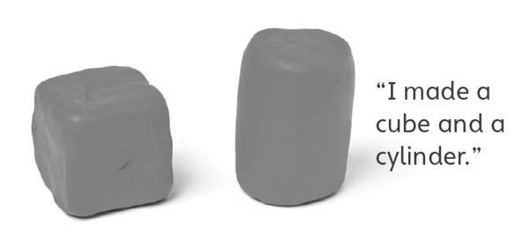
Observations/Documentation

