Identifying 3-D Solids Behaviours/Strategies
- Student looks at a 3-D solid, but  struggles to analyze its geometric attributes.  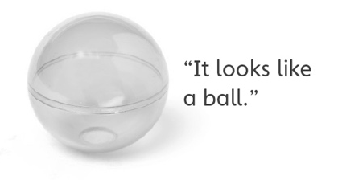 | - Student identifies some 3-D solids in the environment, but struggles when orientation or size of object does not match his or her mental image of solid.  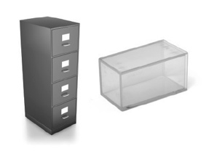 | - Student identifies 3-D solids in  the environment, but struggles to  explain why an object is an example of the given 3-D solid. | - Student successfully analyzes  geometric attributes of 3-D  solids, identifies 3-D solids in the environment, and explains thinking.
Observations/Documentation
Constructing 3-D Solids and Their Skeletons Behaviours/Strategies
- Student chooses materials, but  struggles to construct the solid  with given attributes.  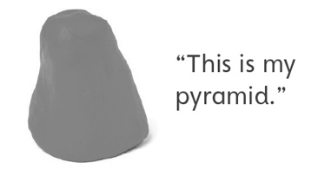 | - Student looks at a 3-D solid, but  struggles to construct skeleton and does not know where to start.  “I don’t know what to do.” | - Student analyzes geometric  attributes of a 3-D solid, but makes error(s) constructing skeleton.  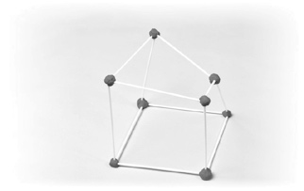 | - Student successfully constructs model and skeleton of a 3-D solid with given attributes.
Observations/Documentation

Big Idea |  |  |  |  | Indicators from Learning Progression
Curriculum Expectations addressed

Student Names
Student can identify geometric and non-geometric attributes of solids.
(Activities 6, 7, 8, 9, 10)
Student can sort solids using two attributes.
(Activities 6, 10)
Student can name familiar 3-D solids.
(Activities 6, 7, 8, 9, 10)
Student can find examples of 3-D solids in the world around them.
(Activity 7, 10)
Student can identify the sorting rule for a sort.
(Activity 6)
Student can build a model of a 3-D solid.
(Activities 8, 10)
Student can explain how two solids are alike and how they are different.
(Activities 6, 7, 8, 9, 10)
Student can build a skeleton of a 3-D solid.
(Activities 9, 10)
Student uses math language when talking about 3-D solids.
(Activities 6, 7, 8, 9, 10)

Name: _______________________

 | Not Observed | Sometimes | Consistently
Identifies geometric and non-geometric attributes of solids.
(Activities 6, 7, 8, 9, 10)
Sorts solids using two attributes.
(Activities 6, 10)
Names familiar 3-D solids.
(Activities 6, 7, 8, 9, 10)
Finds examples of 3-D solids in the world around them.
(Activity 7, 10)
Identifies the sorting rule for a sort.
(Activity 6)
Builds a model of a 3-D solid.
(Activities 8, 10)
Explains how two solids are alike and how they are different.
(Activities 6, 7, 8, 9, 10)
Builds a skeleton of a 3-D solid.
(Activities 9, 10)
Uses math language when talking about 3-D solids.
(Activities 6, 7, 8, 9, 10)

Strengths:

Next Steps:

