**Maps with Grid**

**Master 49a**

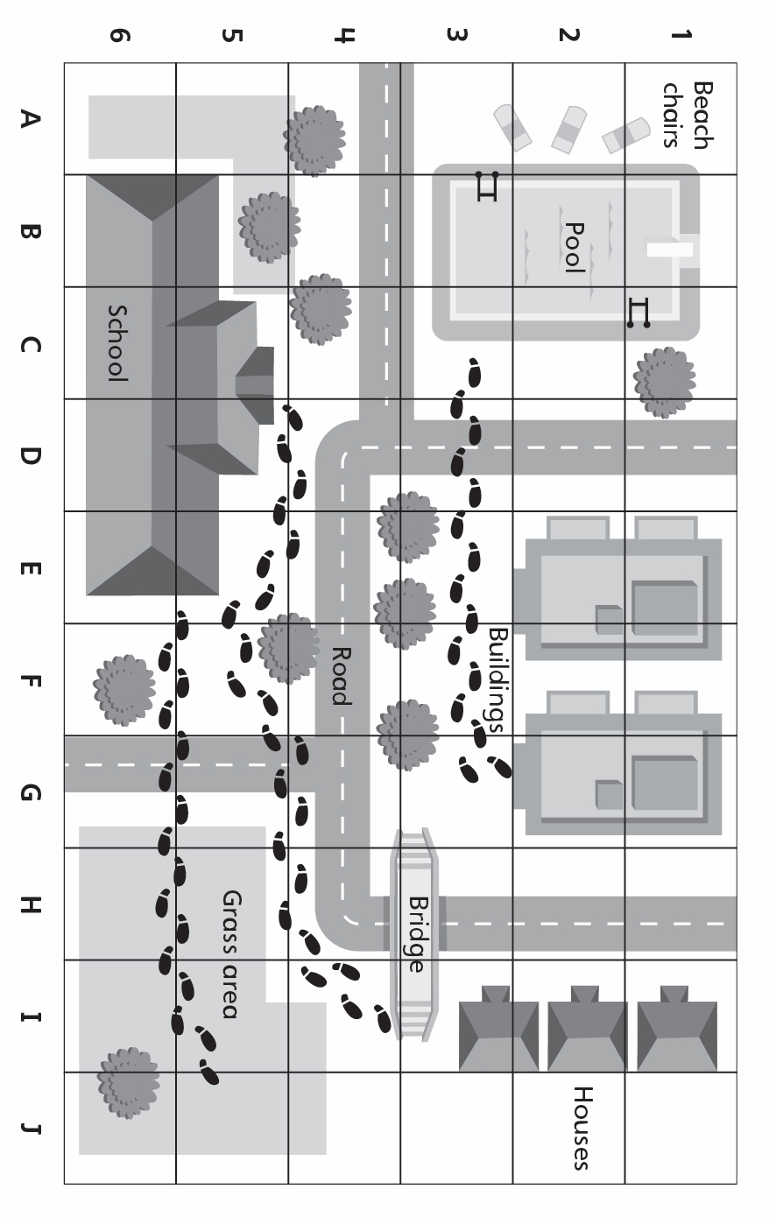

**Maps with Grid**

**Master 49b**

