**My Cube Path**

**Master 59a**

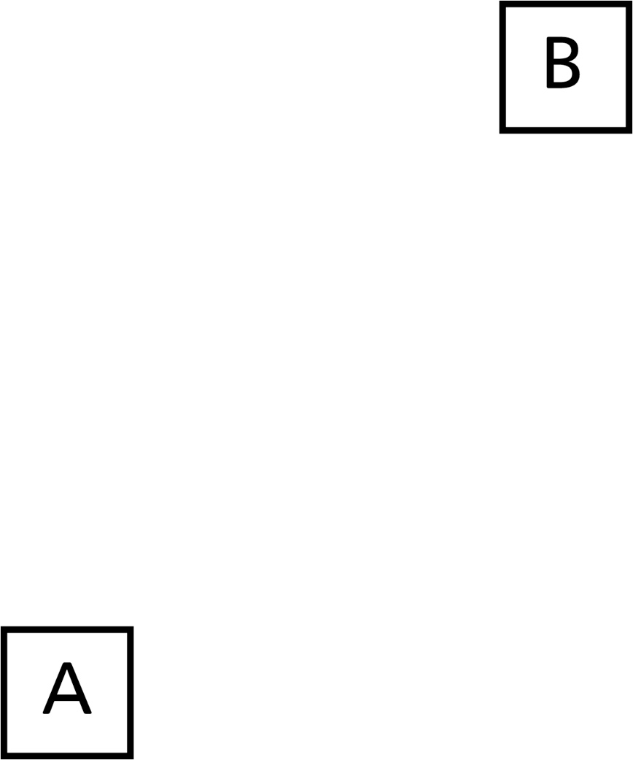

**My Cube Path   
(For Accommodations)**

**Master 59b**

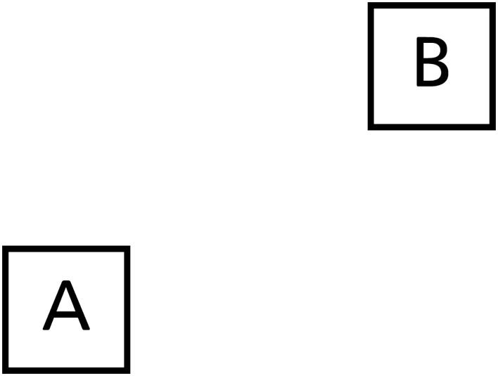

**My Cube Path   
(For Extension)**

**Master 59c**

