Describing Paths with Codes Behaviours/Strategies
- Student creates a path with cubes on a diagonal and struggles to write a code to describe the path.  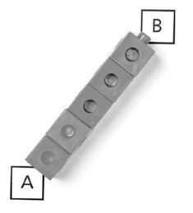 | - Student creates a path with cubes, but struggles to use positional language to write a code to describe the path.  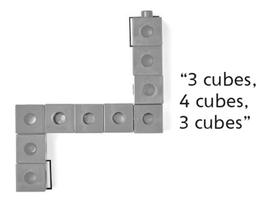 | - Student creates a path with cubes and uses  positional language to write a code to describe  the path, but counts the same cube twice.  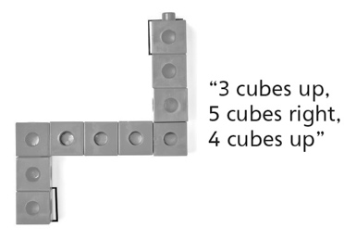
Observations/Documentation
- Student creates a path with cubes and uses  positional language to write a code to describe  the path from A to B, but starts over to write a  code from B to A.  “I don’t know what to do to write a code to go  from B to A. I’ll start over.” | - Student creates a path with cubes and uses  positional language to write codes to describe  the paths from A to B and B to A, but starts over to find another path.  “Let me take all the cubes off and start over.” | - Student creates different paths with cubes and  successfully uses positional language to write  codes to describe the paths from A to B and  B to A.
Observations/Documentation

