Reading and Writing Code on Grids Behaviours/Strategies
- Student describes the movement from one  location to another on a grid, but code is not  accurate.  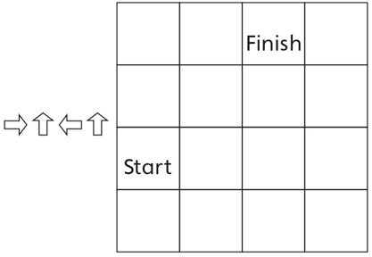 | - Student describes the movement from one  location to another on a grid, but writes code by counting squares instead of steps, resulting in one extra arrow.  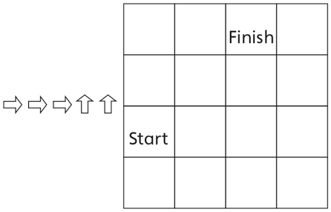 | - Student describes the movement from one  location to another on a grid and accurately  writes code, but struggles to check if partner’s  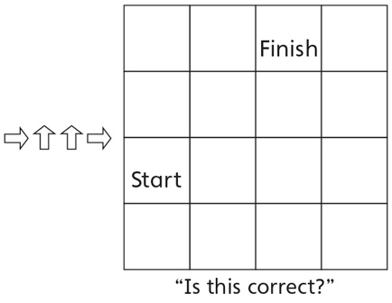  code is correct.
Observations/Documentation
- Student describes the movement from one  location to another on a grid and writes accurate code, but struggles to write code from memory.  “How can I write the code without  seeing the grid?” | - Student describes the movement from one  location to another on a grid and writes code  from memory, but there are small mistakes. | - Student describes the movement from one  location to another on a grid and writes accurate codes, with and without seeing a grid.
Observations/Documentation

