Analyzing Geometric Attributes of 2-D Shapes Behaviours/Strategies
- Student analyzes geometric attributes of 2-D  shapes, but is only able to identify one shape  with a given attribute.  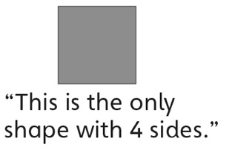 | - Student analyzes geometric attributes of 2-D  shapes, but thinks that shapes that are oriented differently do not have the attribute.  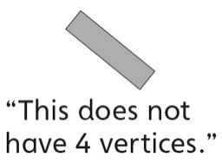 | - Student analyzes geometric attributes of 2-D  shapes, but only identifies familiar shapes as  having the given attribute.  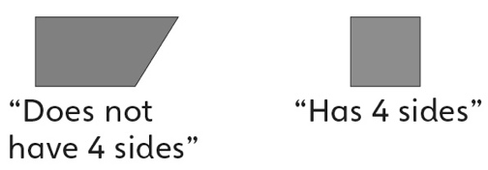
Observations/Documentation
- Student analyzes geometric attributes of 2-D  shapes (number of sides), but struggles to  identify shapes by number of vertices.  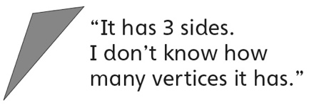 | - Student successfully analyzes geometric  attributes of 2-D shapes, but struggles to draw  another shape that has the given geometric  attribute.  “I don’t know what to draw.” | - Student successfully analyzes geometric  attributes of 2-D shapes and draws another  shape that has the given geometric attribute.
Observations/Documentation

