Using Positional Language Behaviours/Strategies
- Student chooses an object, but is  unable to use relative positions  to describe the location of the  object (does not know positional  language). | - Student uses gestures to describe the locations of objects, but is uncomfortable with most  positional language.  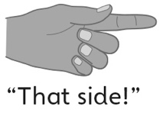 | - Student uses relative positions to  describe the locations of objects,  but struggles with a few positional words such as right and left.  “To the left. No, to the right.” | - Student fluently uses relative  positions to describe the locations of objects.  “Beside the desk, on your left.”  “The only thing above the flag.”
Observations/Documentation

