Measuring Other Animals
Intervention: Master 54a

How long is my neck?
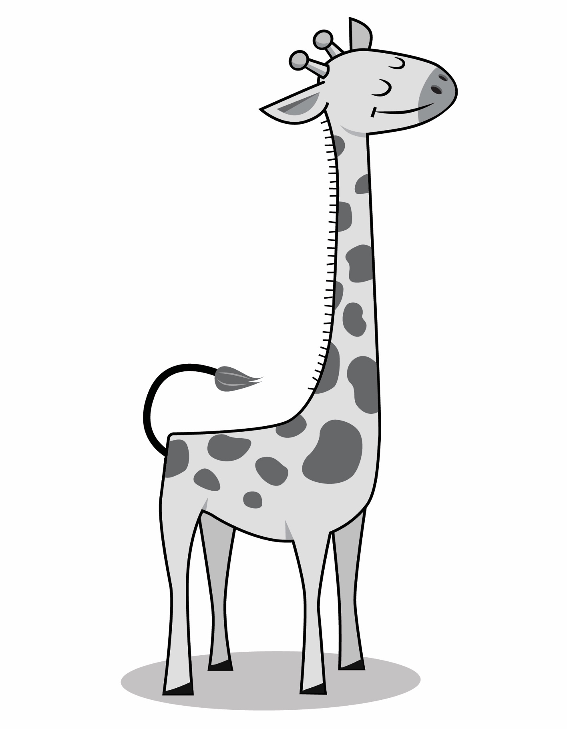
Measuring Other Animals
Intervention: Master 54b

How long are my ears?
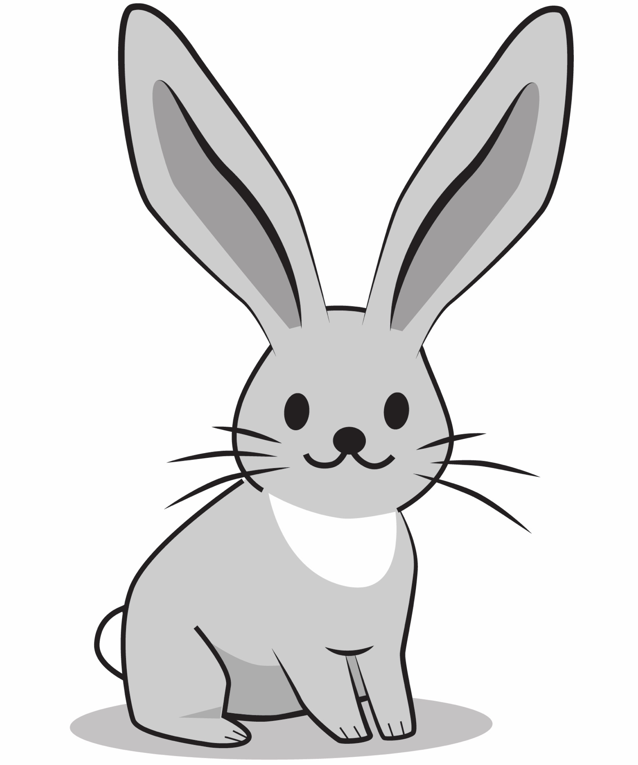
Measuring Other Animals
Intervention: Master 54c

How long is my tail?
