Decomposing 10 Behaviours/Strategies
- Student places 10 beads on bracelet, but does not know that rearranging the beads does not change the quantity (conservation of number).  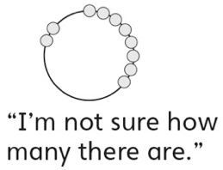 | - Student decomposes 10 into two  parts, but does not remember the  whole (counts three times to say  how many).  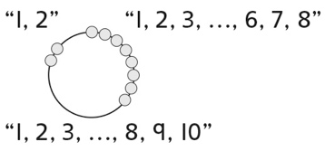 | - Student decomposes 10 into two  parts, but does not remember the  whole (counts on from a part to  say how many).  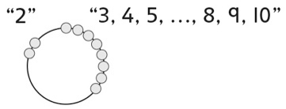 | - Student decomposes 10 into two  parts, but starts again to find a  new way.  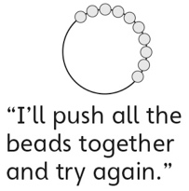
Observations/Documentation
- Student decomposes 10 into two  parts, but moves beads randomly  to find different ways.  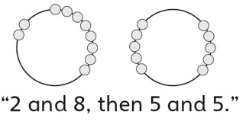 | - Student finds possible ways to  decompose 10 into two parts, but  does not consider zero. | - Student uses patterns to  successfully find different ways to  decompose 10 into two parts.  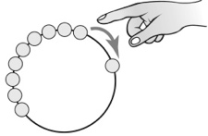 | - Student uses known number  relationships to successfully find  all possible ways to decompose 10 into two parts.  0 + 10 = 10 6 + 4 = 10  1 + 9 = 10 7 + 3 = 10  2 + 8 = 10 8 + 2 = 10  3 + 7 = 10 9 + 1 = 10  4 + 6 = 10 10 + 0 = 10  5 + 5 = 10
Observations/Documentation

