**Ten-Frame Cards**

**Intervention: Master 32**

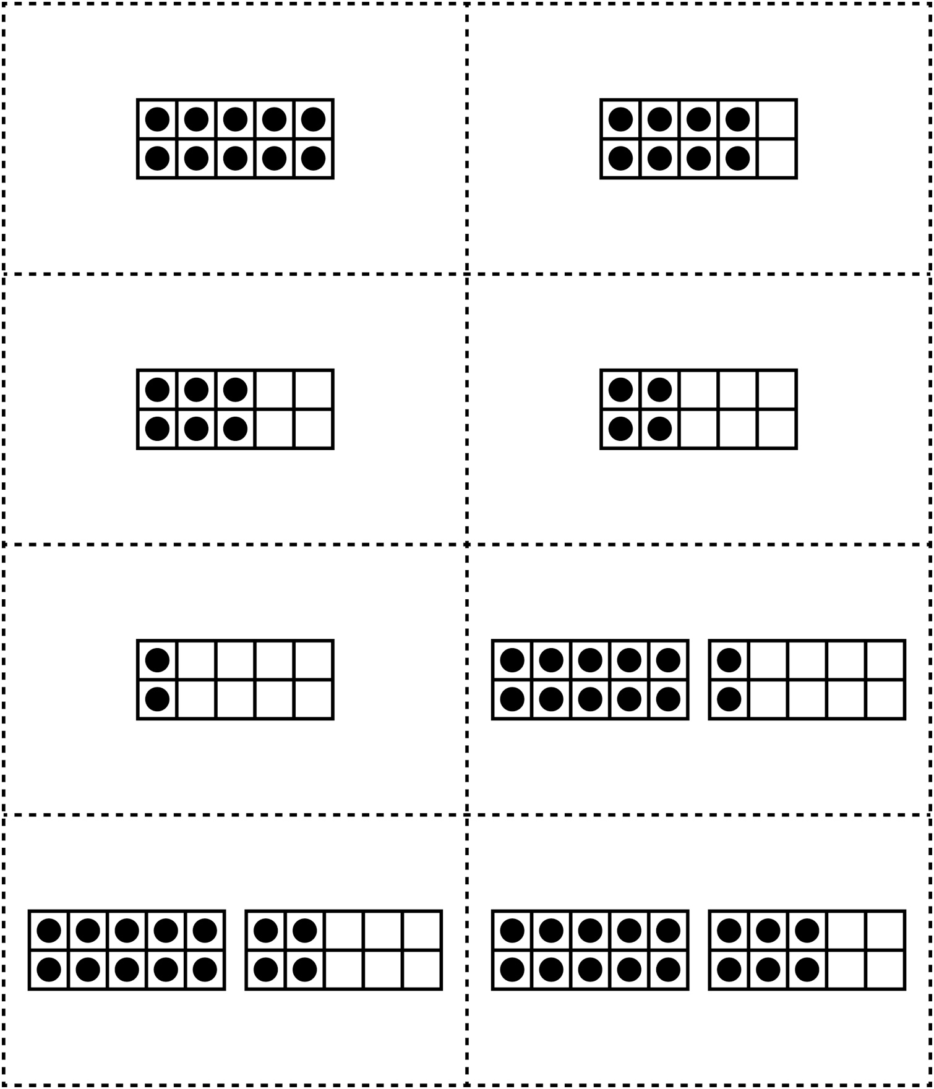

**Ten-Frame Cards**

**Intervention: Master 32**

