Grouping Objects to Find How Many Behaviours/Strategies
- Student counts by 1s rather than grouping  objects, but mixes up number sequence or does not coordinate number words with counting actions.  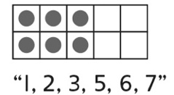 | - Student accurately counts by 1s, but does not  group objects.  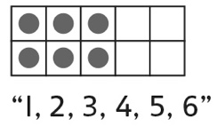 | - Student groups objects by 2s and skip-counts.  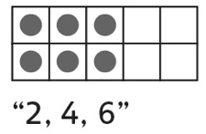
Observations/Documentation
- Student groups some objects and subitizes, and then counts on by 1s.  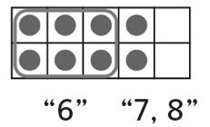 | - Student groups objects by 10s (uses structure of ten-frame to determine how many).  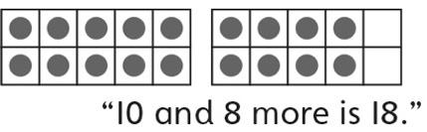 | - Student groups objects flexibly and uses number relationships to determine how many.  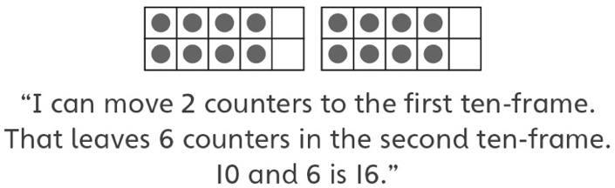
Observations/Documentation

