**Sample Graphs**

**Math Every Day: Master 21a**

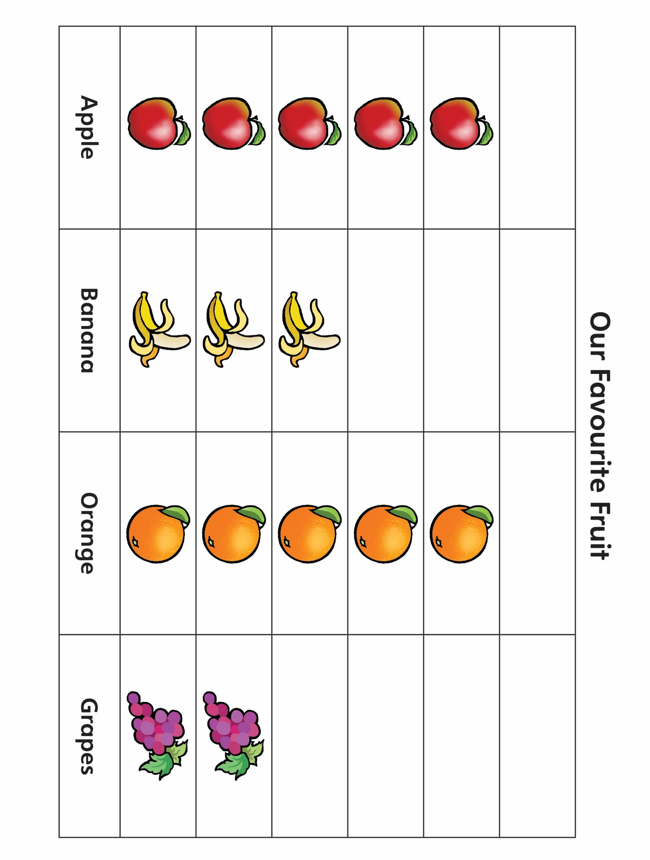

**Sample Graphs**

**Math Every Day: Master 21b**

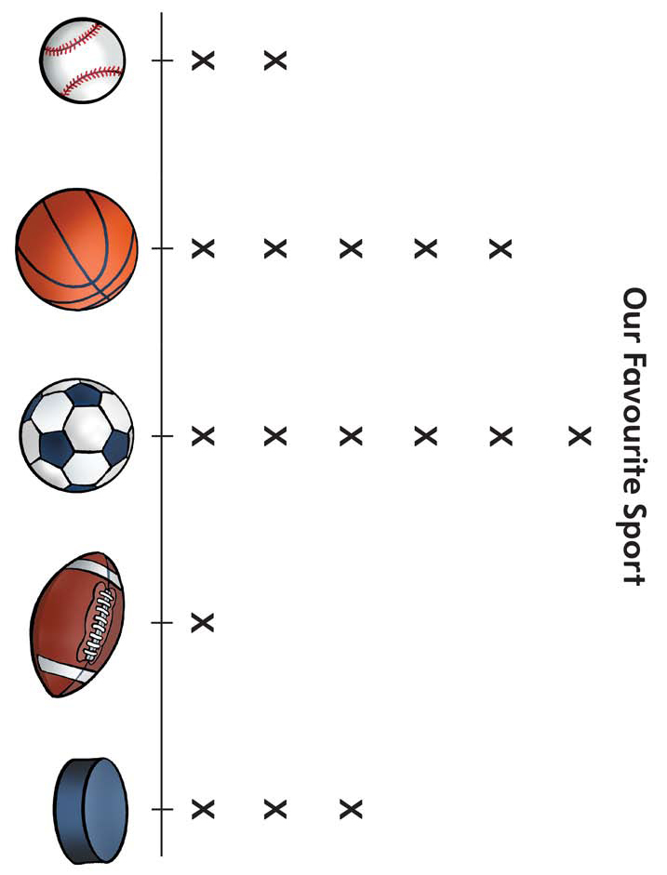

**Sample Graphs**

**Math Every Day: Master 21c**

