**Number Cards (1–12)**

**Math Every Day: Master 9a**

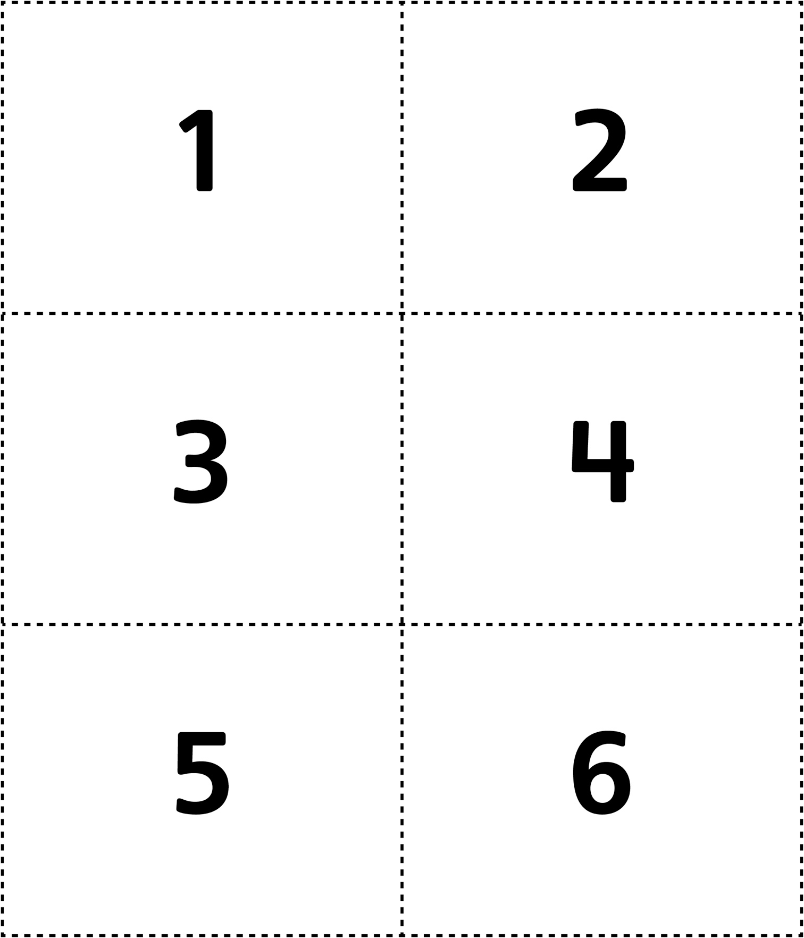

**Number Cards (1–12)**

**Math Every Day: Master 9b**

