**Garden Designs**

**Master 11**

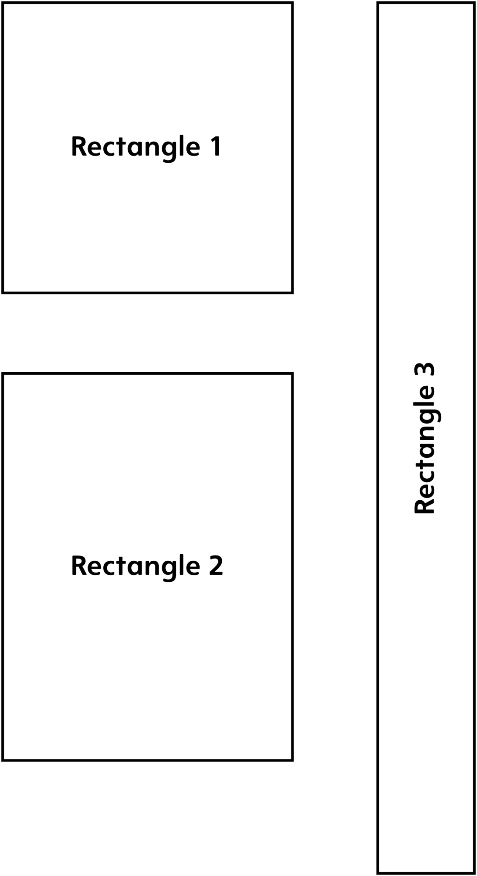

Which rectangle do you think is the biggest?

Circle one:

1 2 3