Measurement Recording Sheet
Master 16a

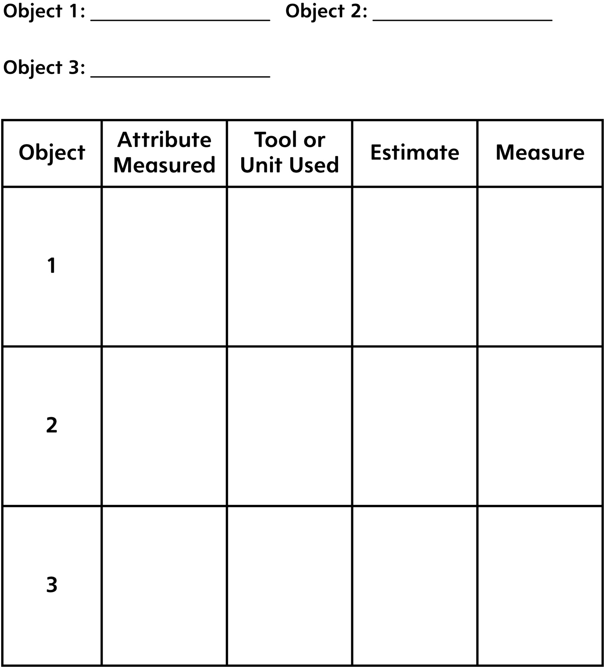

Measurement Recording Sheet
Master 16b

Write one thing that is important to remember when measuring:
Length:

Mass:

Area:

Capacity:

