Measuring Length in Metres Behaviours/Strategies
- Student struggles to estimate length using  a standard unit (metre), and the estimate is  extreme or unreasonable.  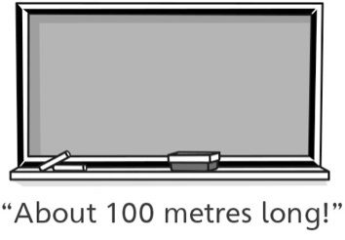 | - Student measures length using a standard unit (metre), but does not line up the end of the metre stick with the end of the object being measured.  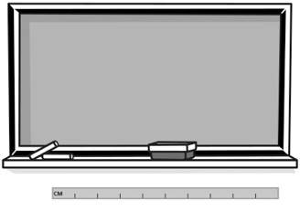 | - Student measures length using a standard unit  (metre), but struggles to iterate the metre  stick (leaves gaps or overlaps, or has difficulty  tracking the metre stick while measuring).
Observations/Documentation
- Student measures length using a standard  unit (metre), but loses track of the count when  measuring.  “I forget how many metre sticks I used.” | - Student measures length using a standard unit (metre), but forgets to include the unit when stating the measure or ignores leftover.  “It is 7 long.” | - Student successfully estimates and measures  length using a standard unit (metre) and  includes units with measures.  “The whiteboard is a little less than  3 metres long.”
Observations/Documentation

