Choosing an Appropriate Unit and Estimating Length Behaviours/Strategies
- Student chooses an object, but  struggles to select an appropriate  standard unit to measure length.  “I will use centimetres to measure the length of the  teeter-totter.” | - Student selects an appropriate  standard unit and tool to measure length, but cannot justify choice.  “I just know metres is what  I should use.” | - Student selects an appropriate  standard unit, but the estimate is  extreme or unreasonable. | - Student successfully selects an  appropriate standard unit to  measure length, and estimates are reasonable.
Observations/Documentation
Measuring Length in Standard Units Behaviours/Strategies
1. Student measures length using  standard units, but does not line  up the object with the baseline of  the measuring tool.  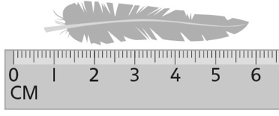 | 2. Student measures length using  standard units, but struggles to  iterate the measuring tool. | 3. Student measures length using  standard units, but forgets to  include the unit when stating the  measure or ignores leftover.  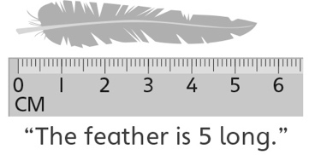 | 4. Student successfully measures  length using standard units and  includes units with measures.  “The feather is a little more than  5 centimetres long.”
Observations/Documentation

Big Idea |  |  |  |  | Indicators from Learning Progression
Curriculum Expectations addressed

Student Names
Student can use benchmarks to estimate and measure length in centimetres and metres.
(Activities 8, 9, 10, 12)
Student can use the metre to estimate and measure length.
(Activity 9, 11, 12)
Student can use the centimetre to estimate and measure length.
(Activities 10, 11, 12)
Student includes a unit
with all measures.
(Activities 8, 9, 10, 11, 12)
Student can choose an appropriate benchmark or standard unit/tool to measure length.
(Activities 8, 11, 12)
Student lines up the object being measured with the baseline of the measuring tool.
(Activities 9, 10, 11, 12)
Student can iterate the measuring tool accurately.
(Activity 8, 9, 10, 11, 12)
Student can deal with lengths that are not a whole number of metres/centimetres long.
(Activities 9, 10, 11, 12)

Name: _______________________

 | Not Observed | Sometimes | Consistently
Uses benchmarks to estimate and measure length in centimetres and metres.
(Activities 8, 9, 10, 12)
Uses the metre to estimate and measure length.
(Activity 9, 11, 12)
Uses the centimetre to estimate and measure length.
(Activities 10, 11, 12)
Includes a unit with all measures.
(Activities 8, 9, 10, 11, 12)
Chooses an appropriate benchmark or standard unit/tool to measure length.
(Activities 8, 11, 12)
Lines up the object being measured with the baseline of the measuring tool.
(Activities 9, 10, 11, 12)
Iterates the measuring tool accurately.
(Activity 8, 9, 10, 11, 12)
Deals with lengths that are not a whole number of metres/centimetres long.
(Activities 9, 10, 11, 12)

Strengths:

Next Steps:

