**Calendar Puzzle Cards**

**Master 34a**

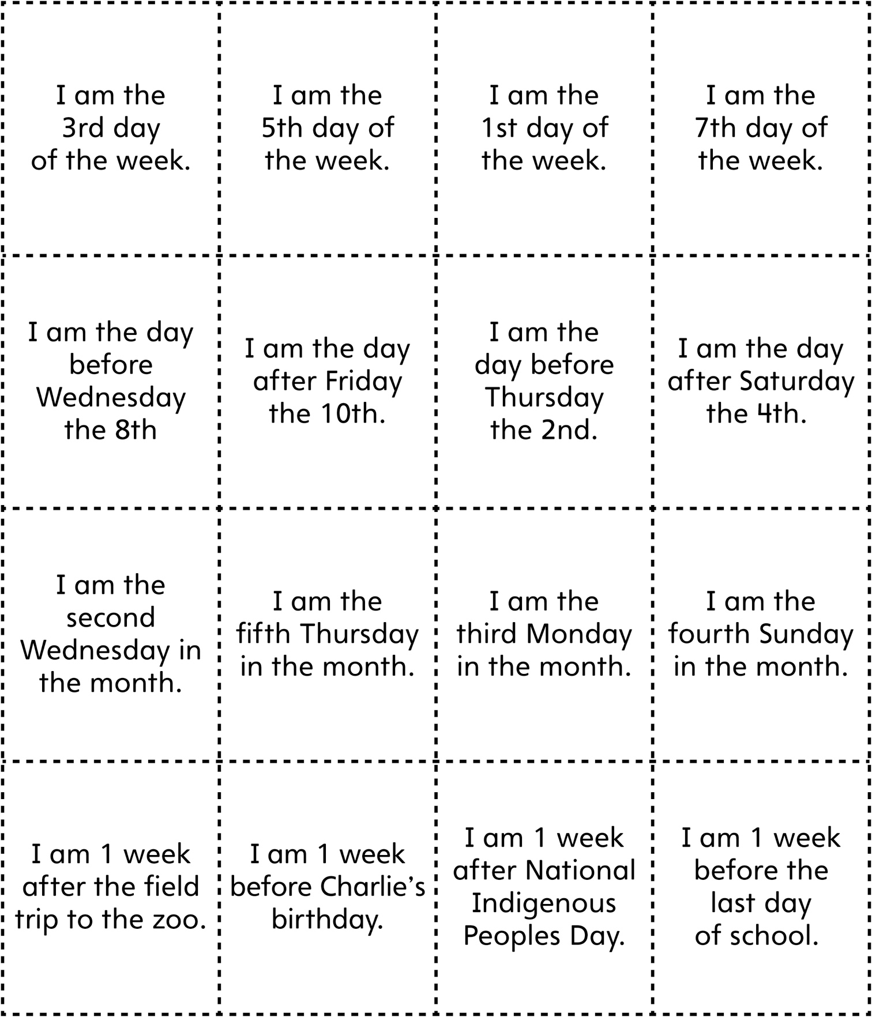

**Calendar Puzzle Cards   
(for Accommodations)**

**Master 34b**

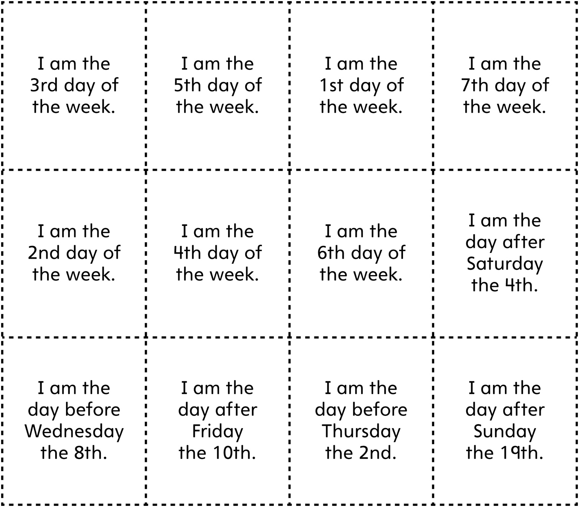

**Calendar Puzzle Cards**

**Master 34c**

**(for Extension)**

