Relating Days and Weeks Behaviours/Strategies
- Student chooses a card, but does not know  or cannot read the days of the week on the  calendar. | - Student reads the days on the calendar, but  struggles with the use of ordinal numbers in  context.  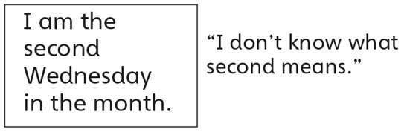 | - Student chooses a card, but struggles to count  forward or backward 7 from a given number to  count on or back one week.
Observations/Documentation
- Student understands the attributes of a calendar, but does not recognize patterns on a calendar page. | - Student understands the attributes of a  calendar, but does not provide a complete  description when providing a date.  “Monday 6th” or “Monday 6” | - Student understands the relationship of units  of time (e.g., days and weeks) and successfully  solves all calendar problems.
Observations/Documentation

