Digital Clock Cards
Master 43a

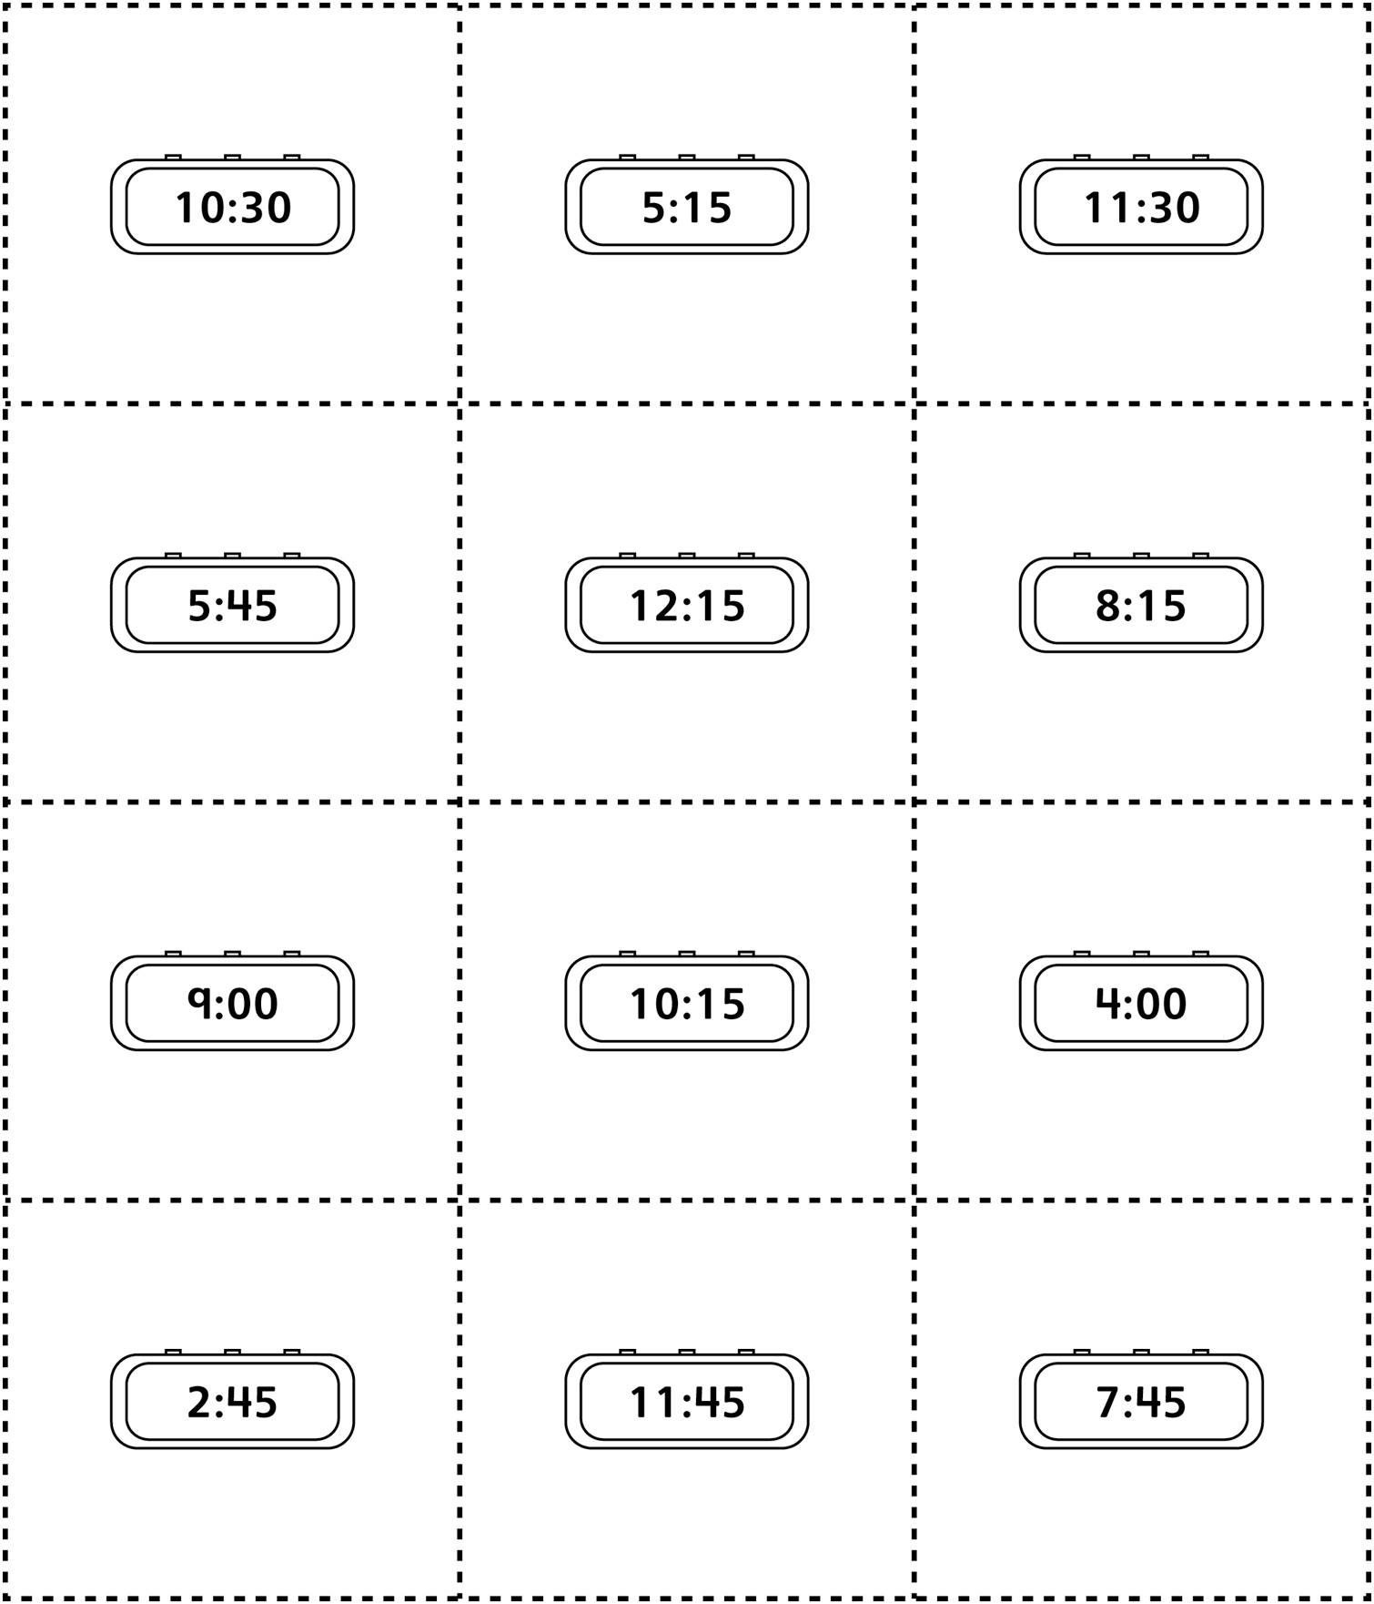

Digital Clock Cards
(for Combined Grades Extension)
Master 43b

